**B. M.S. COLLEGE OF ENGINEERING**

# **(Autonomous College under VTU)**

**Bull Temple Road, Basavangudi, Bangalore - 560019**



# **MACHINE LEARNING LAB**

**(20CS6PCMAL)**

**Report**

***Submitted by***

**MD SURAJ KUMAR (1BM20CS079)**

**VI B**

***in partial fulfillment for the award of the degree of***

**BACHELOR OF ENGINEERING**

***in***

**COMPUTER SCIENCE AND ENGINEERING**

**Lab Incharge**

**ANTARA ROY CHOUDHURY**

**Assistant Professor**

**M. Tech, CSE**

**2023-2024**

**LIST OF PROGRAMS**

|  |  |  |
| --- | --- | --- |
| **Exp. No.** | **Name of the Program** | **Page No.** |
| 1 | FIND-S   1. enjoySport data set 2. purchase data set | 08  17 |
| 2 | CANDIDATE-ELIMINATION ALGORITHM   1. enjoySPort data set 2. purchase data set | 19  26 |
| 3 | DECISION TREE BASED 1D3 ALGORITHM   1. climate data set   a.climate data set | 28 |
| 4 | NAÏVE BAYESIAN CLASSIFIER   1. climate data set | 42 |
| 5 | BAYESIAN NETWORK   1. heart data set | 62 |
| 6 | K-MEANS ALGORITHM   1. blobs data set | 46 |
| 7 | EM ALGORITHM   1. diabetes data set | 51 |
| 8 | K-NEAREST NEIGHBOUR ALGORITHM   1. blobs data set | 57 |
| 9 | LINEAR REGRESSION ALGORITHM   1. Salary data set 2. house prices data set | 36  39 |
| 10 | LOCALLY WEIGHTED REGRESSION ALGORITHM   1. tips data set | 67 |

Date: 01.04.2023

USN: 1BM20CS079

**Program 1 – a) Dataset Exploration – Iris data set**

* Features in the Iris dataset:
  1. sepal length in cm
  2. sepal width in cm
  3. petal length in cm
  4. petal width in cm
* Target classes to predict:
  1. Iris Setosa
  2. Iris Versicolour
  3. Iris Virginica

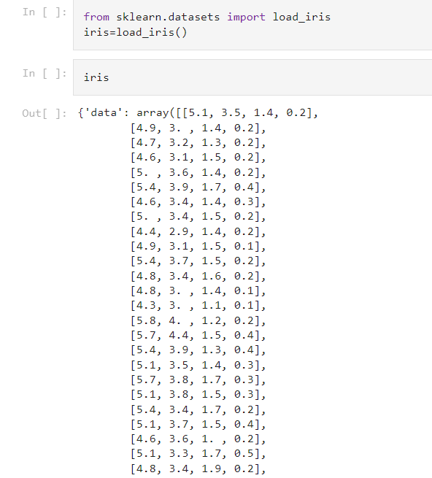

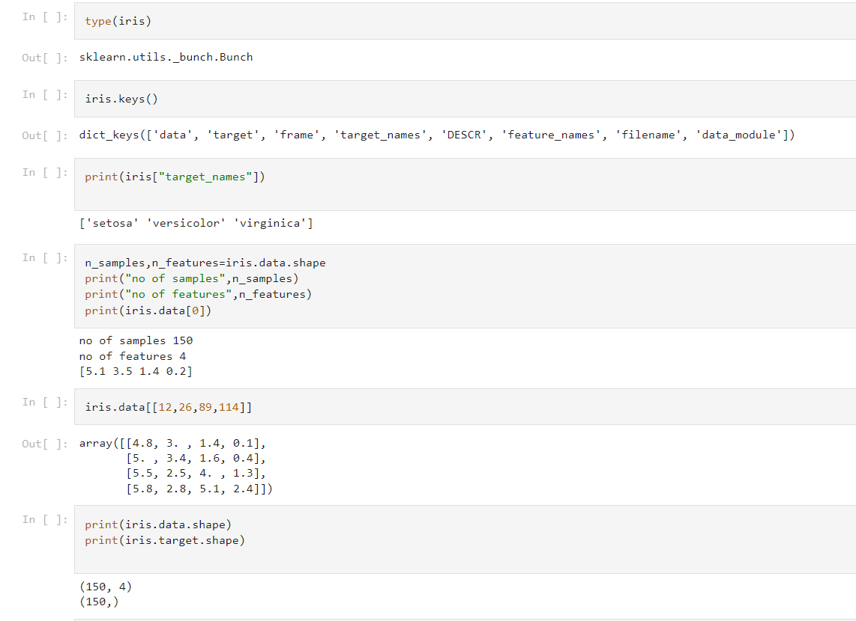

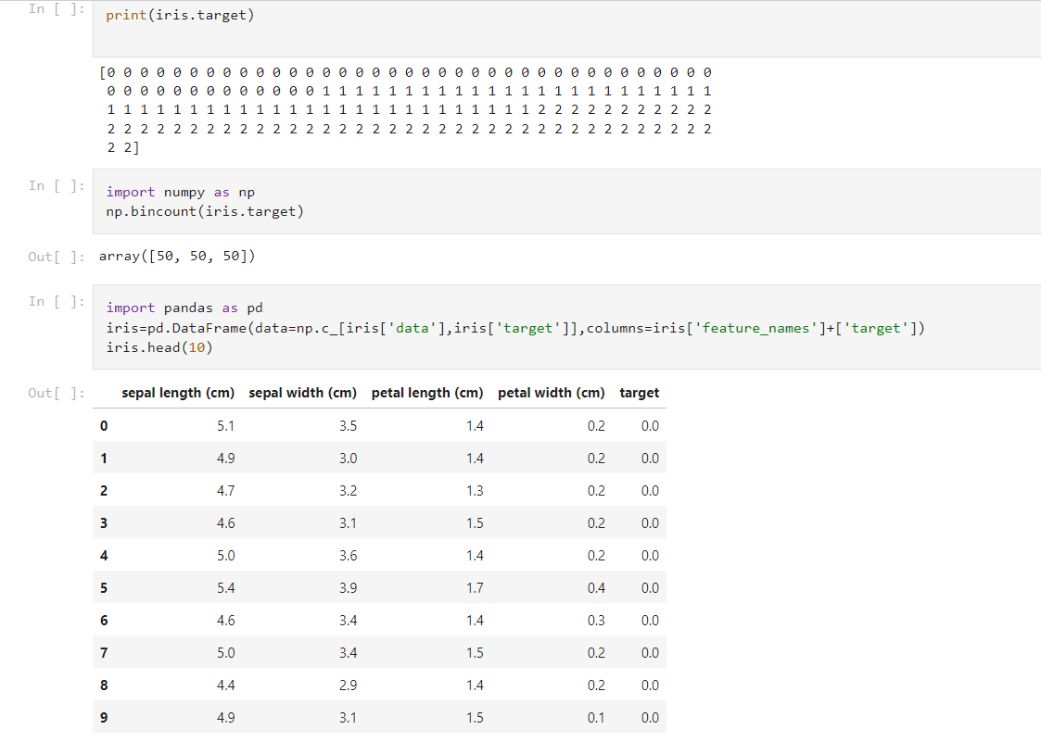

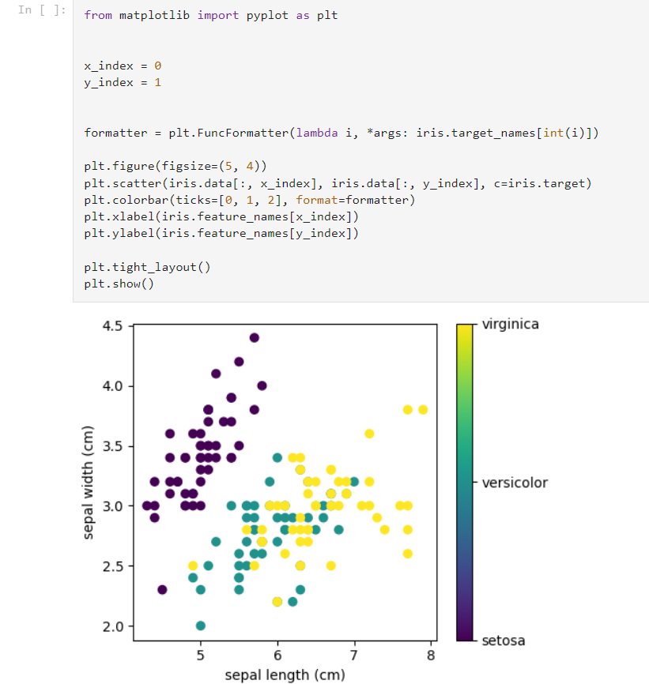

**DESCRIPTION:**

Graph is the illustration of comparision between sepal length and sepal width of the three classes of iris flower i.e, Setosa, virginica, versicolor, depicted by 3 different colours for each category.

**b. Practice Exercise - Dataset Exploration – Wine data set**

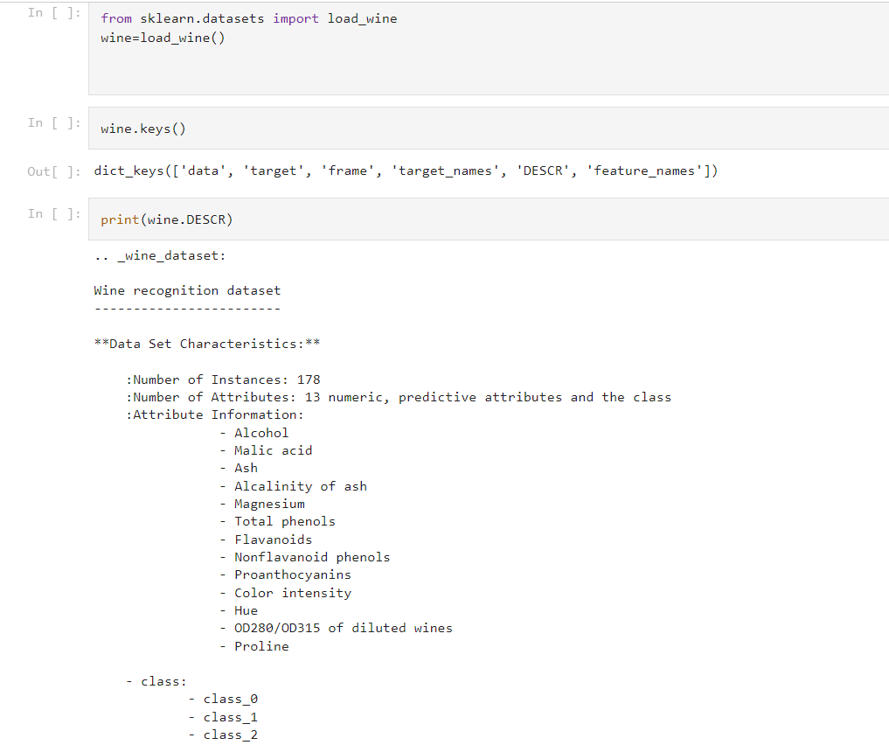

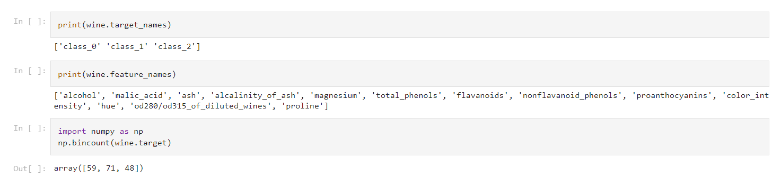

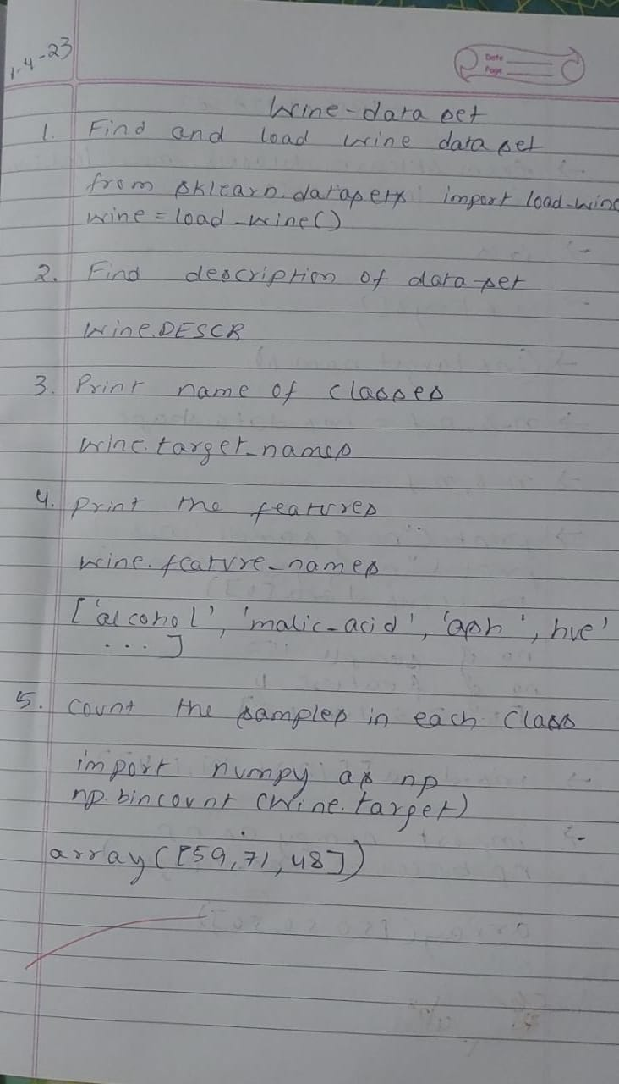

Date: 08.04.2023

Program 2 – Implement and demonstrate the FIND-S algorithm for finding the most specific hypothesis based on a given set of training data samples. Read the training data from a .CSV file

**Data set:**

1. Enjoysport

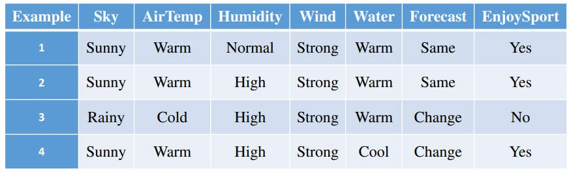

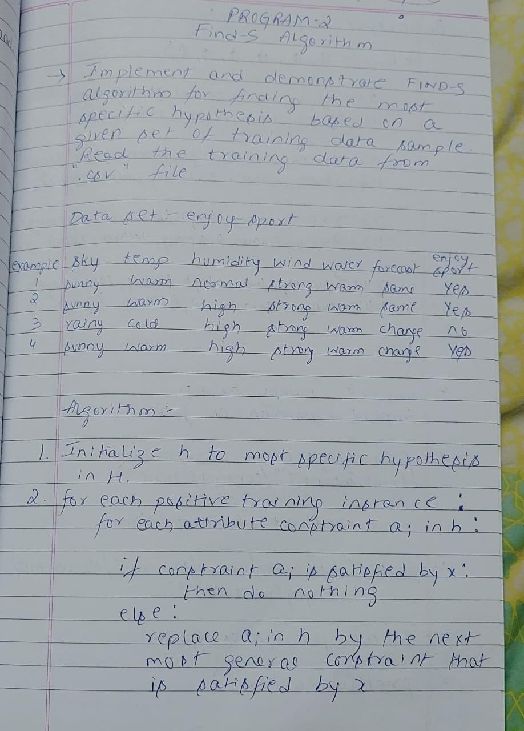

**Algorithm:**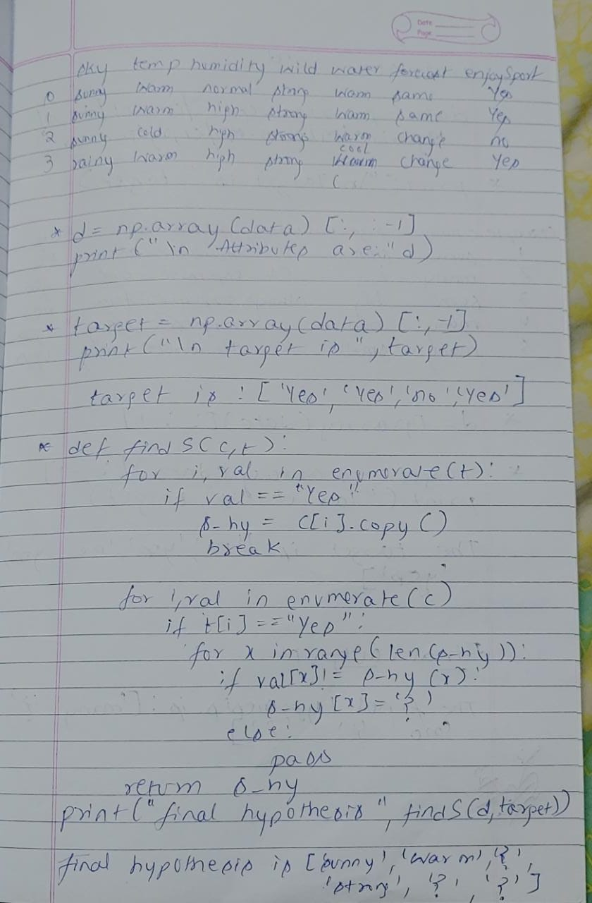

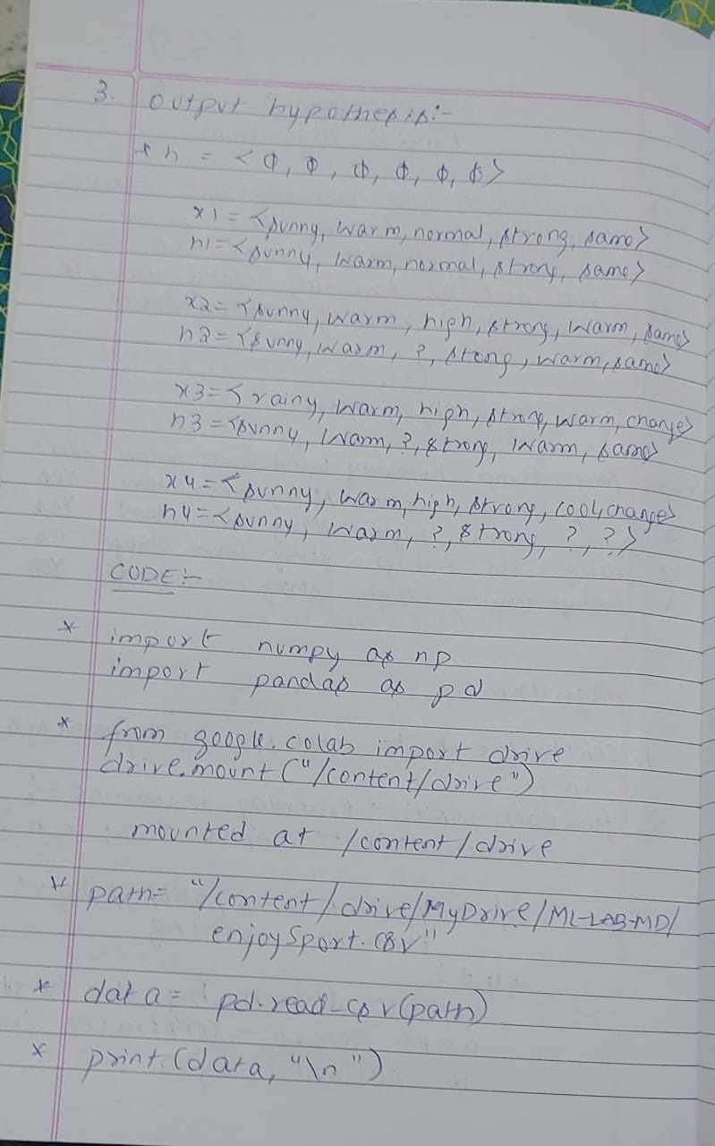

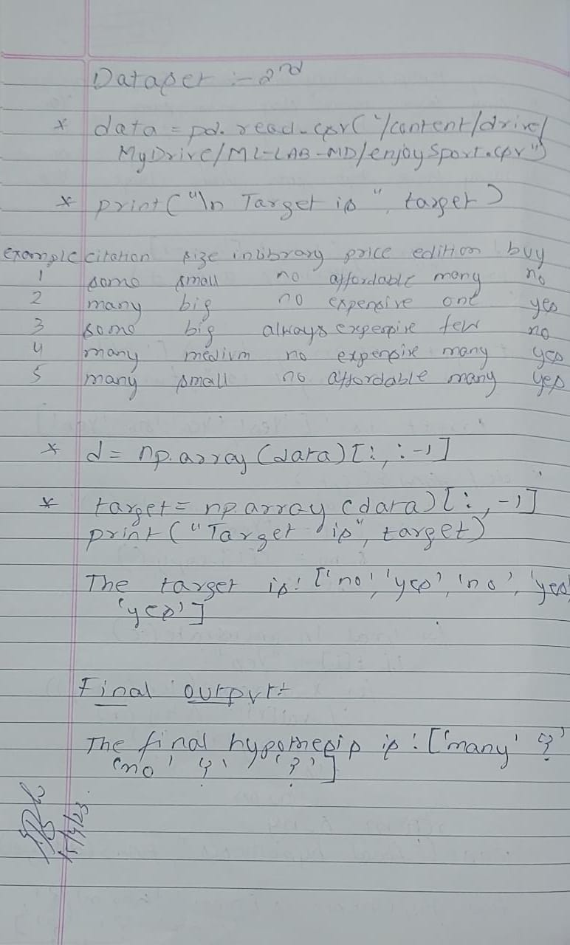

1. The first step of FIND-S is to initialize h to the most specific hypothesis in H **h — (Ø, Ø, Ø, Ø, Ø, Ø)**
2. First training example x1 = < Sunny, Warm, Normal, Strong ,Warm ,Same>, EnjoySport = +ve. Observing the first training example, it is clear that hypothesis h is too specific. None of the “Ø” constraints in h are satisfied by this example, so each is replaced by the next more general constraint that fits the example **h1 = < Sunny, Warm, Normal, Strong ,Warm, Same>**.
3. Consider the second training example x2 = < Sunny, Warm, High, Strong, Warm, Same>, EnjoySport = +ve. The second training example forces the algorithm to further generalize h, this time substituting a “?” in place of any attribute value in h that is not satisfied by the new example. Now **h2 =< Sunny, Warm, ?, Strong, Warm, Same>**
4. Consider the third training example x3 =< Rainy, Cold, High, Strong, Warm, Change>,EnjoySport = — ve. The FIND-S algorithm simply ignores every negative example. So the hypothesis remain as before, so **h3 =< Sunny, Warm, ?, Strong, Warm, Same>**
5. Consider the fourth training example x4 =<Sunny,Warm,High,Strong, Cool,Change>, EnjoySport =+ve. The fourth example leads to a further generalization of h as **h4 =< Sunny, Warm, ?, Strong, ?, ?>**
6. So the final hypothesis is **< Sunny, Warm, ?, Strong, ?, ?>**

**Uploading the csv file:**

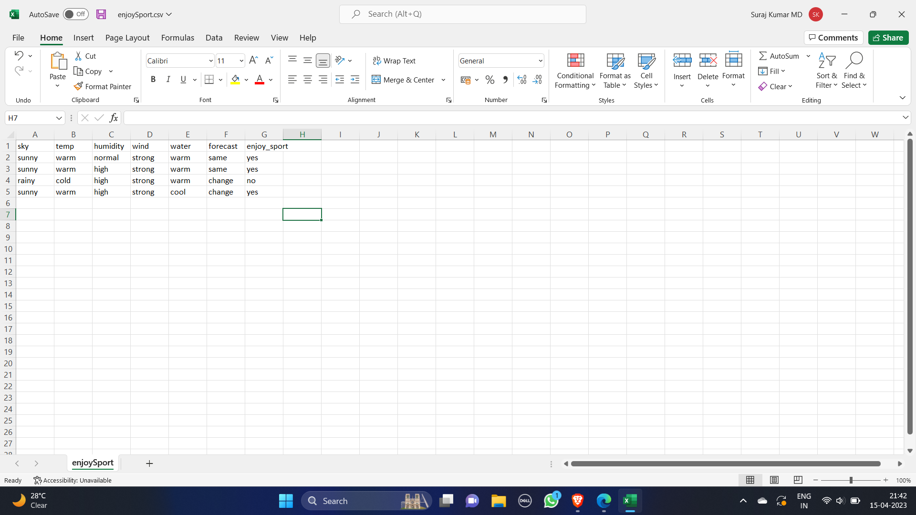

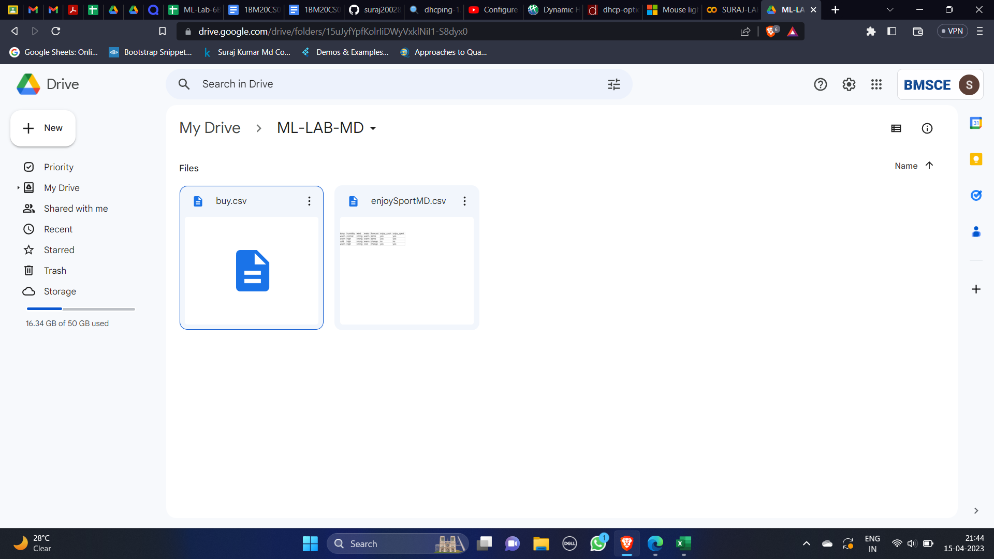

**a. enjoySport.csv**

**Program:**

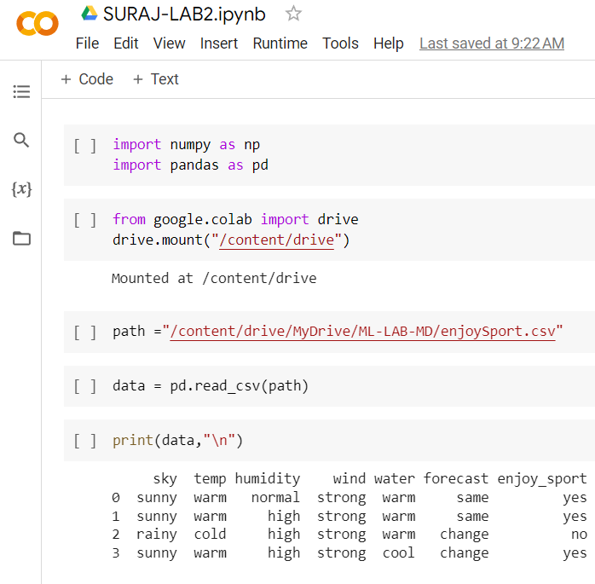

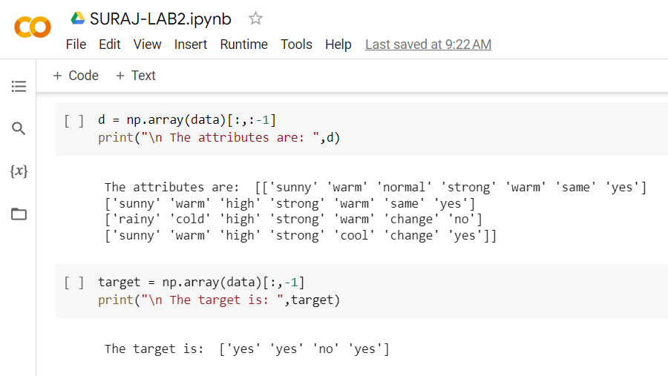

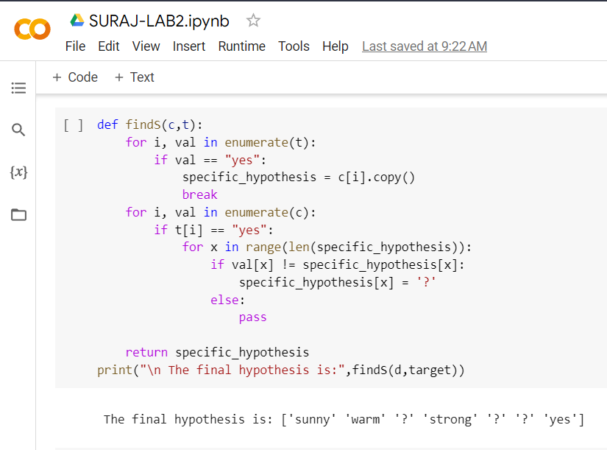

**Output:**

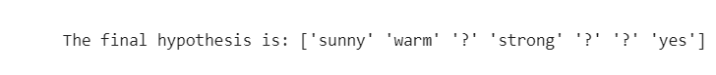

**b. Purchase.csv**

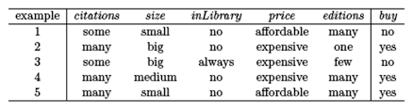

**Uploading the csv file:**

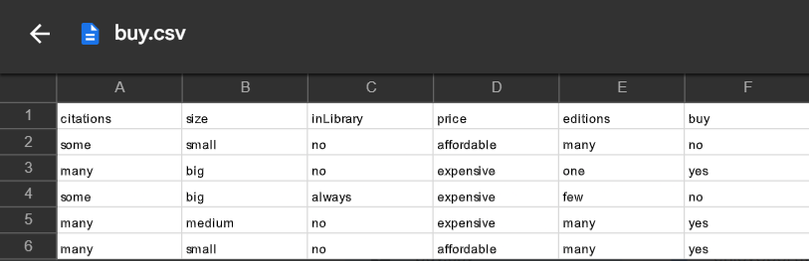

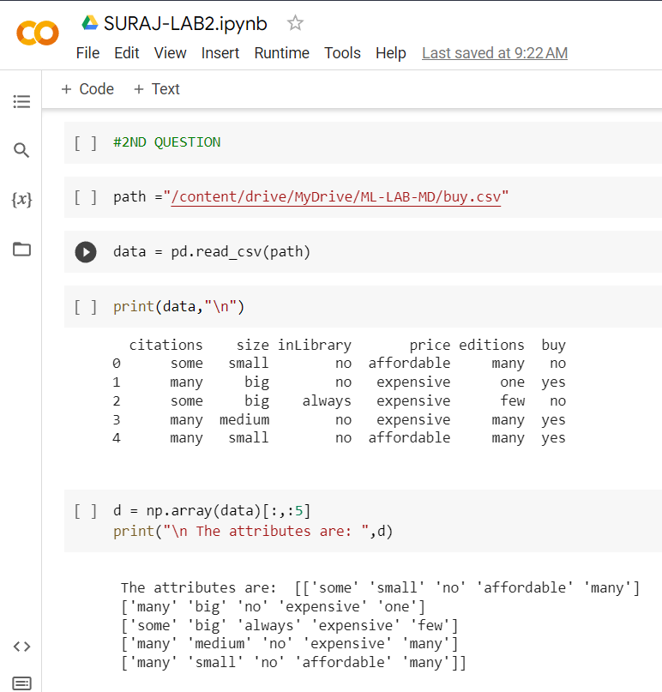

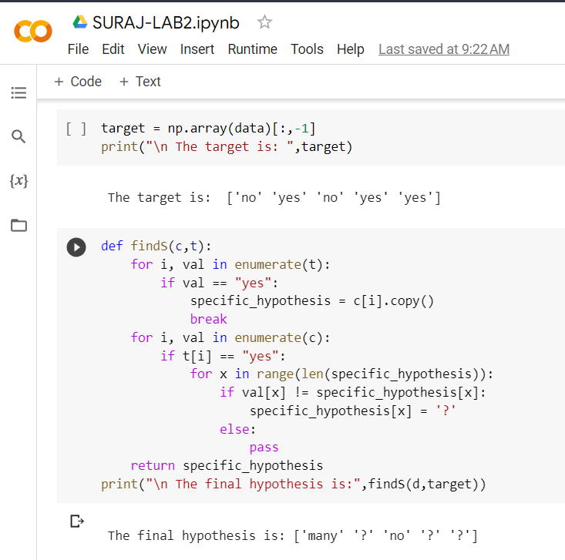

**Output**



**Date: 15.04.2023**

**Program 3:**

For a given set of training data examples stored in a .CSV file, implement and demonstrate the Candidate-Elimination algorithm to output a description of the set of all hypotheses consistent with the training examples.

Dataset : Enjoysport

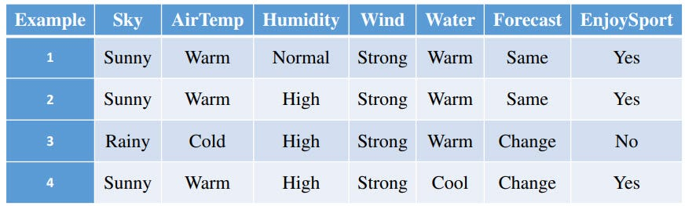

**Algorithm:**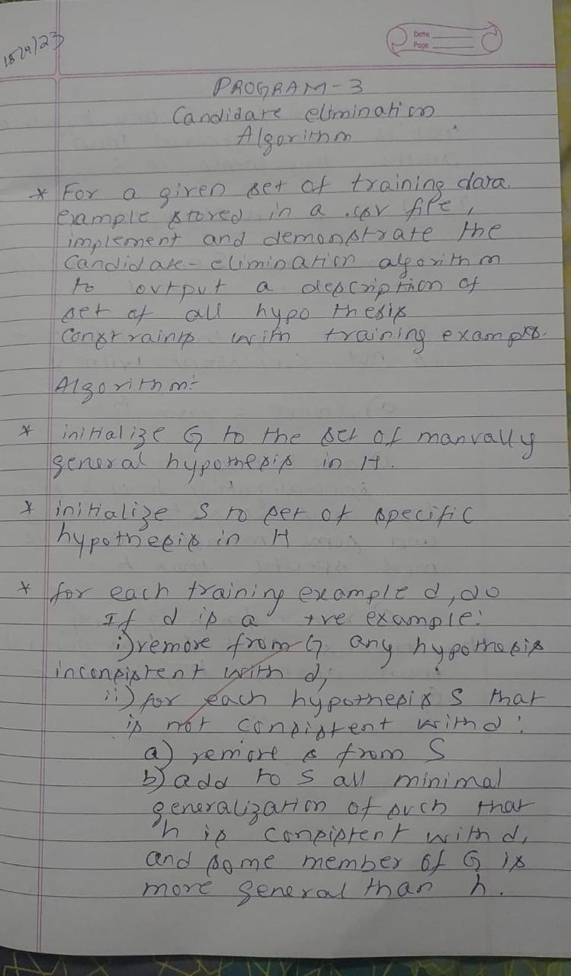

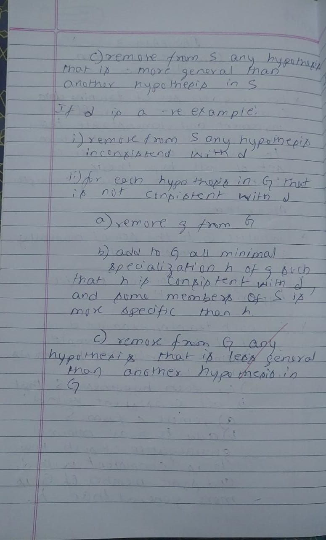

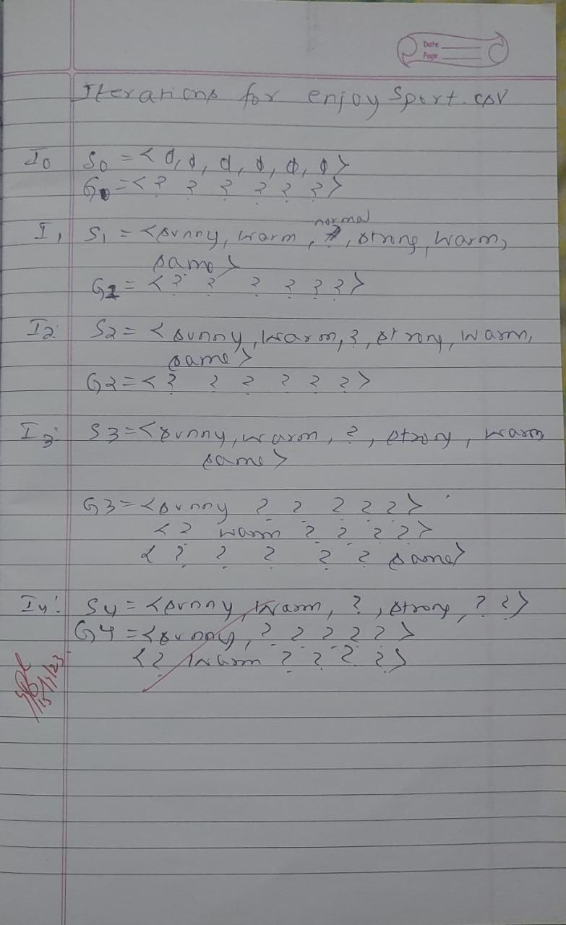

**Uploading the csv file:**





**Program:**

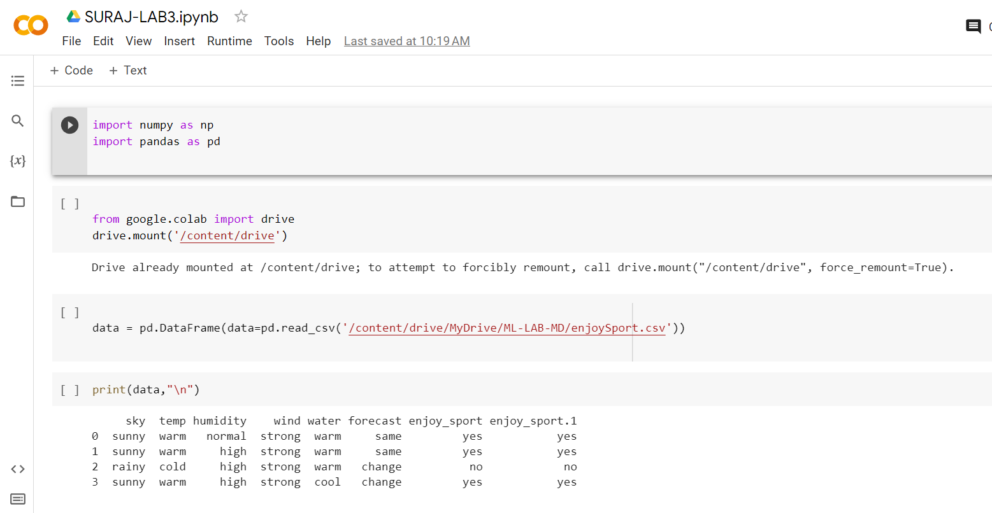



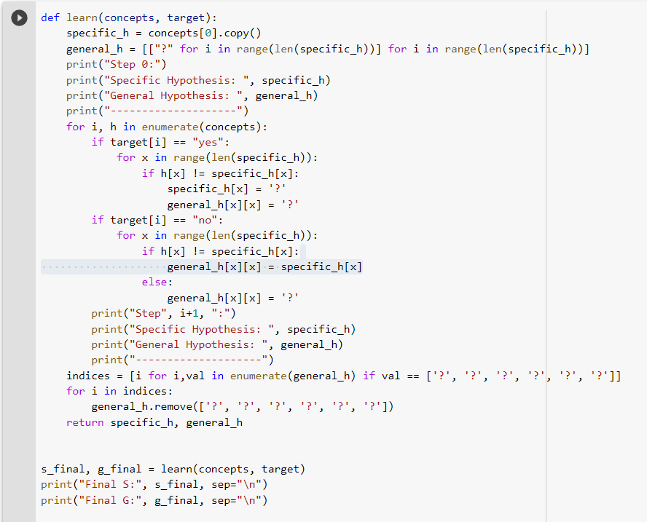

**Output:**

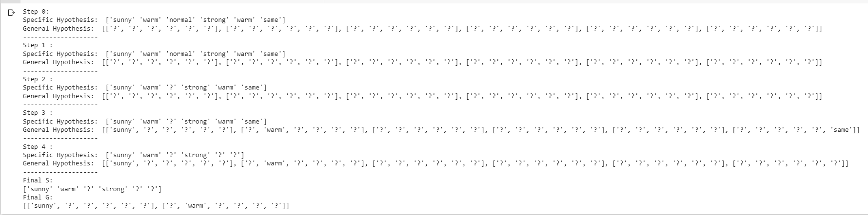

**b. Purchase.csv**



**Uploading the csv file:**



**Program:**

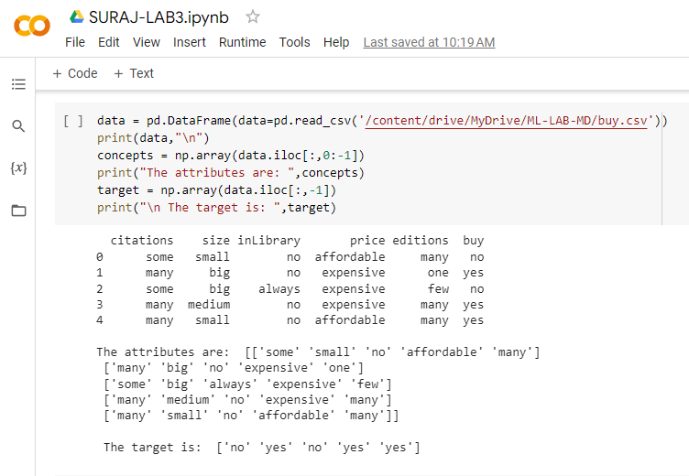

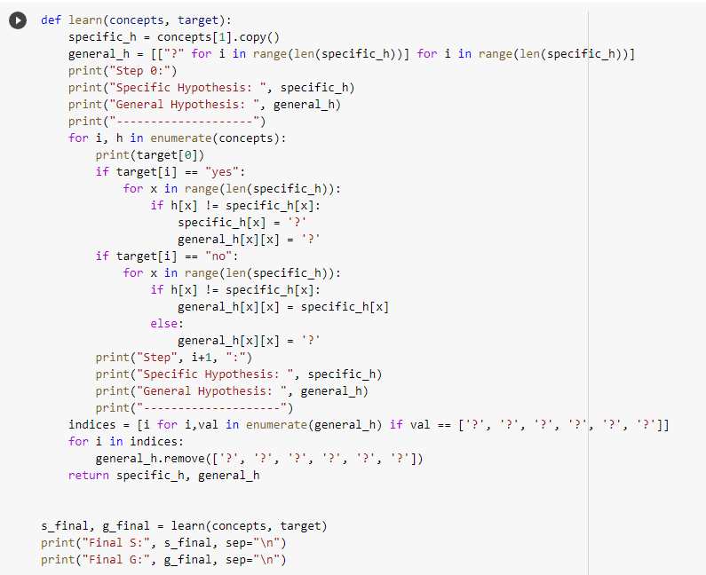

**Output:**

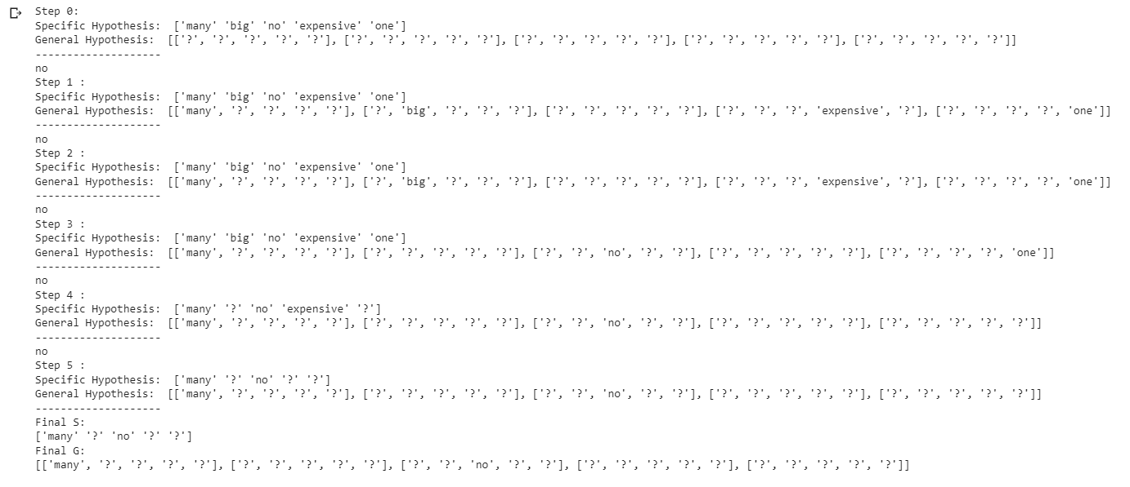

**Date: 29.04.2023**

**Program 4:**

Write a program to demonstrate the working of the decision tree based ID3 algorithm. Use an appropriate data set for building the decision tree and apply this knowledge to classify a new sample.

Dataset : Climate(Forecast)

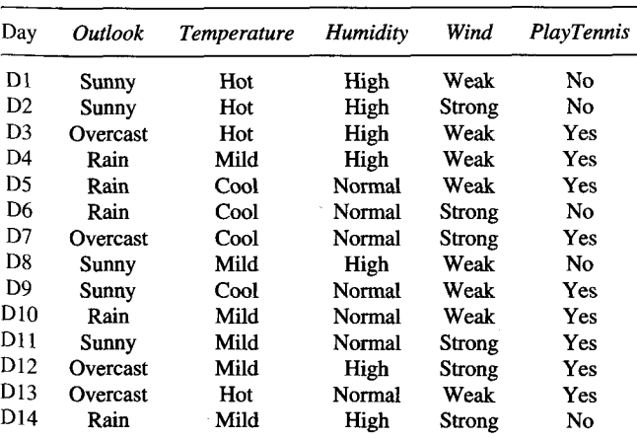

**Algorithm:**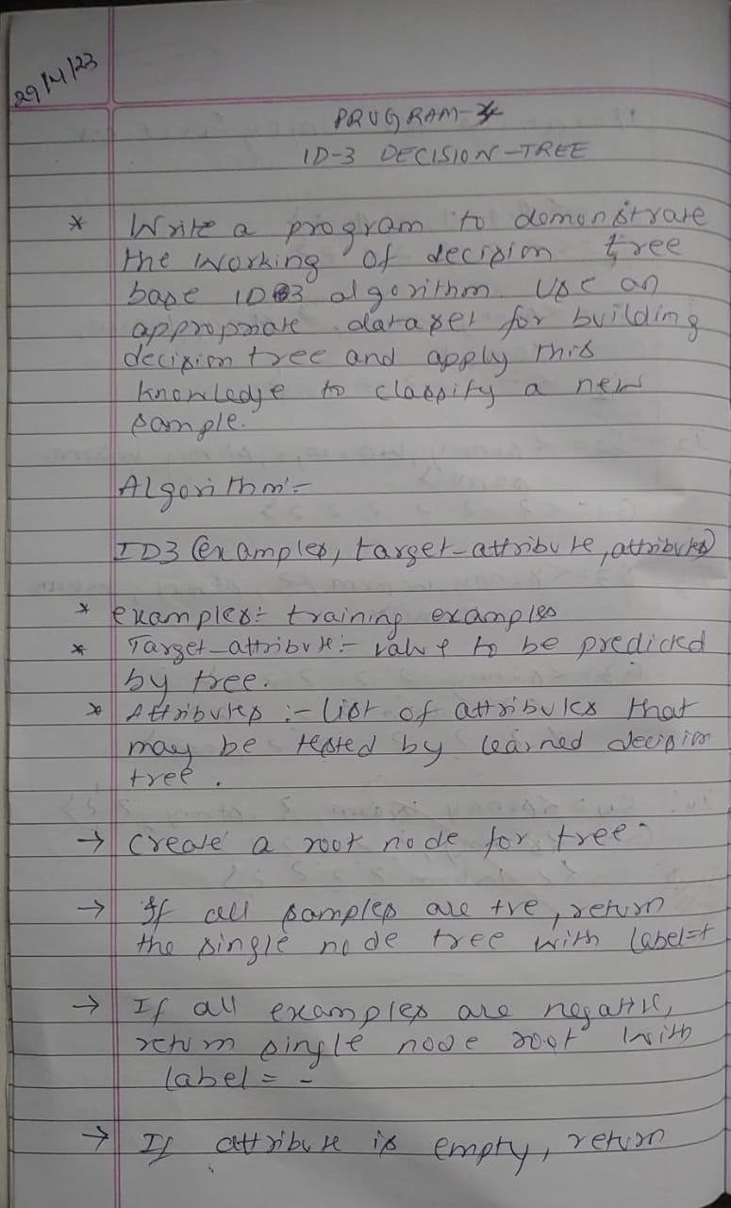

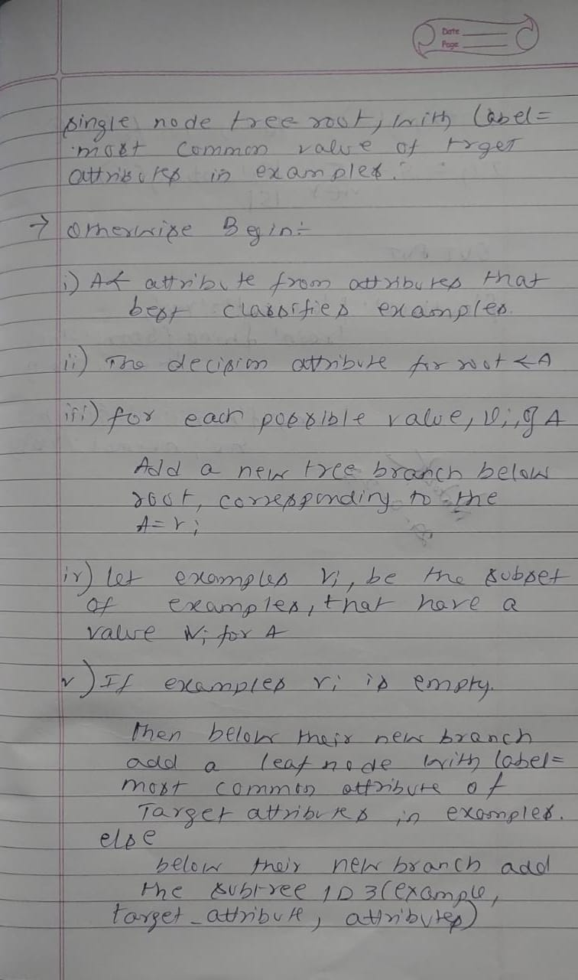

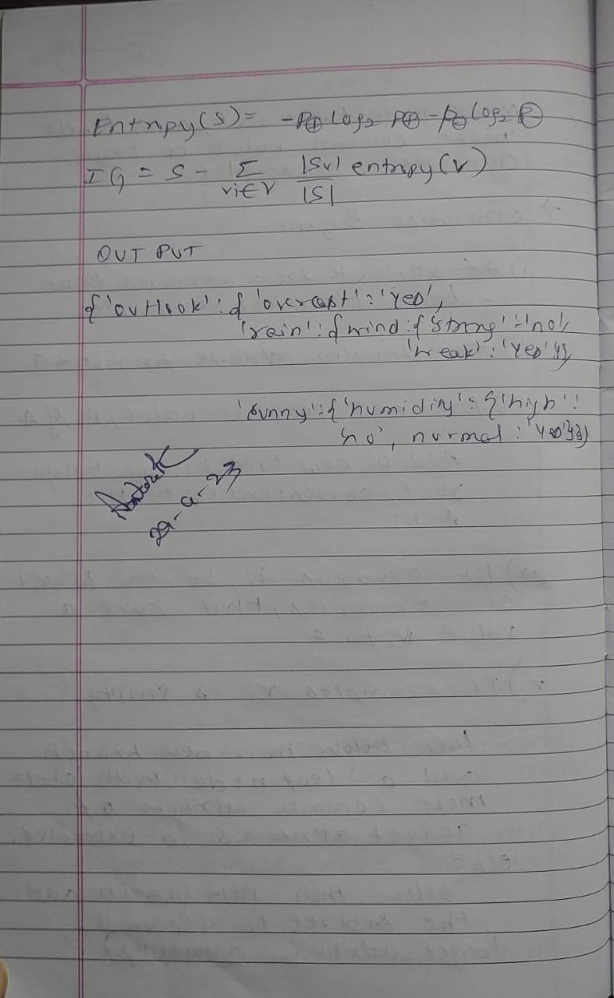

**Uploading the csv file:**

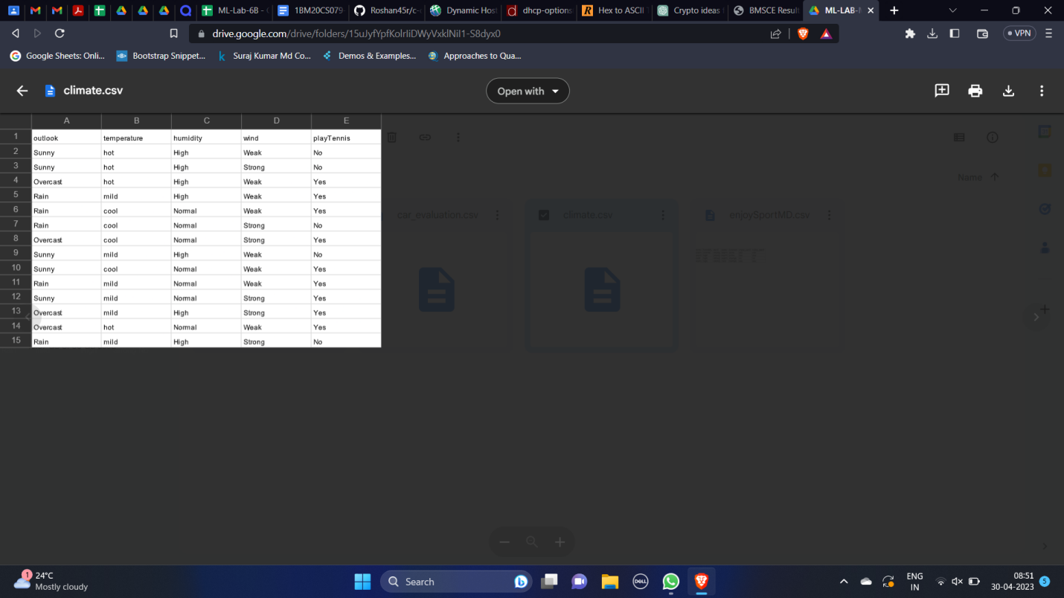

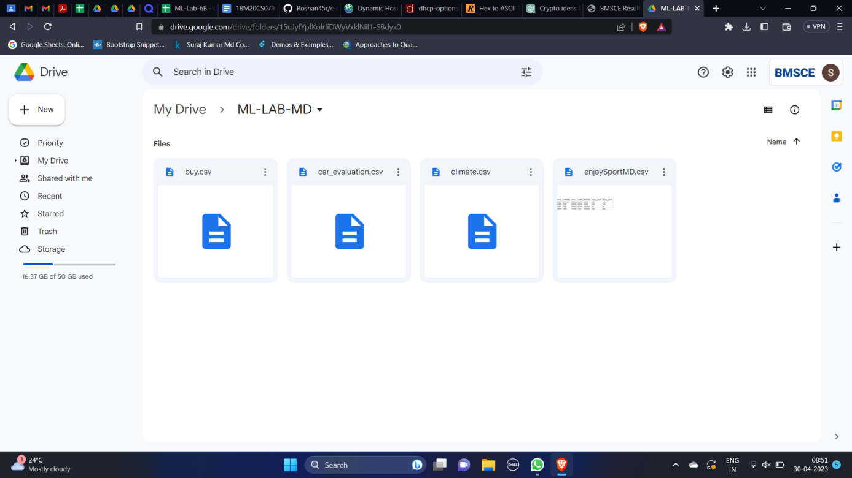

**Program:**

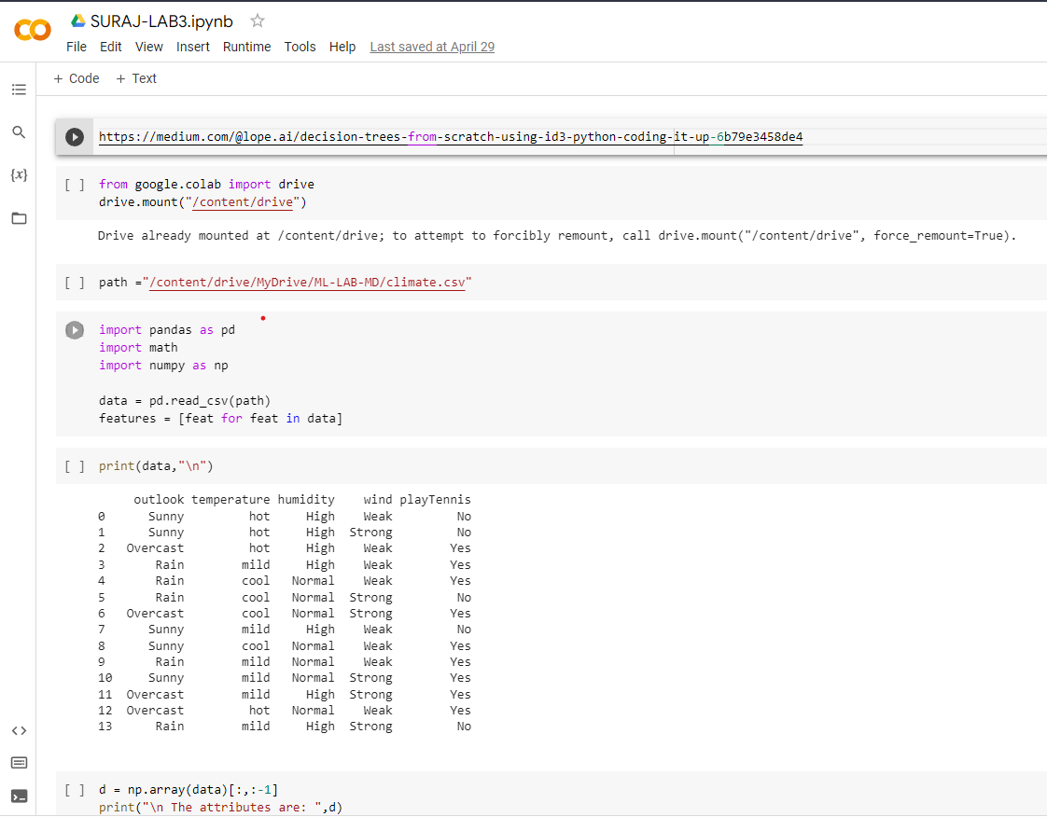

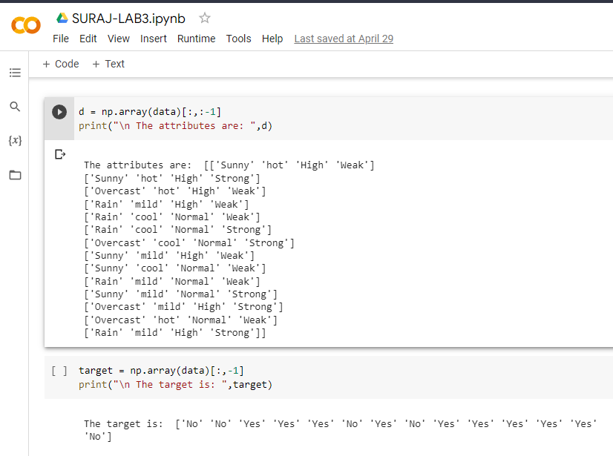

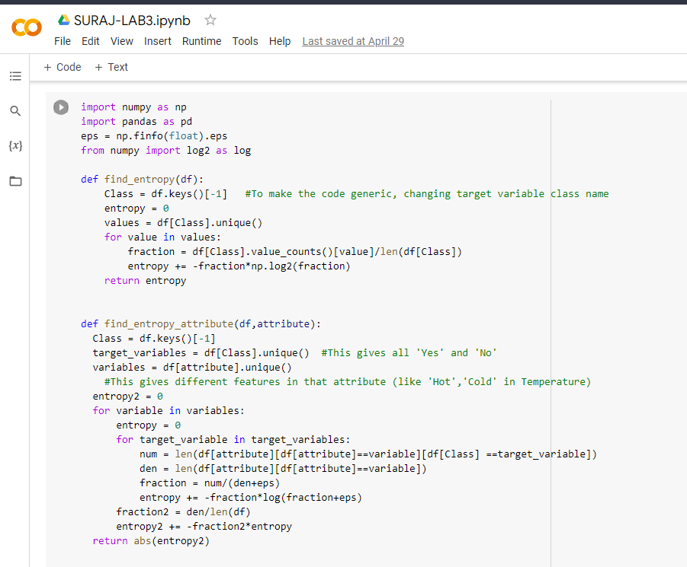

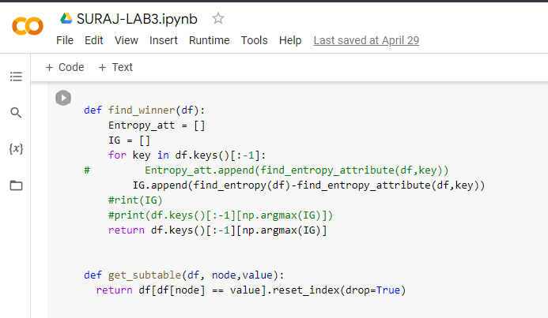

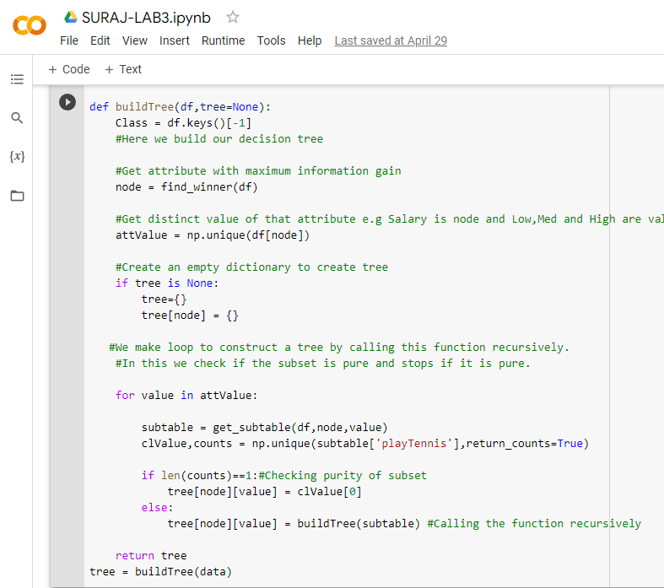

**Output:**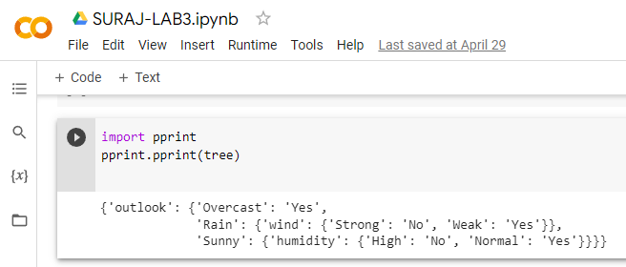

**Date: 29.04.2023**

**Program 5:**

Write a program to demonstrate the working of Linear Regression

Dataset : Salary.csv

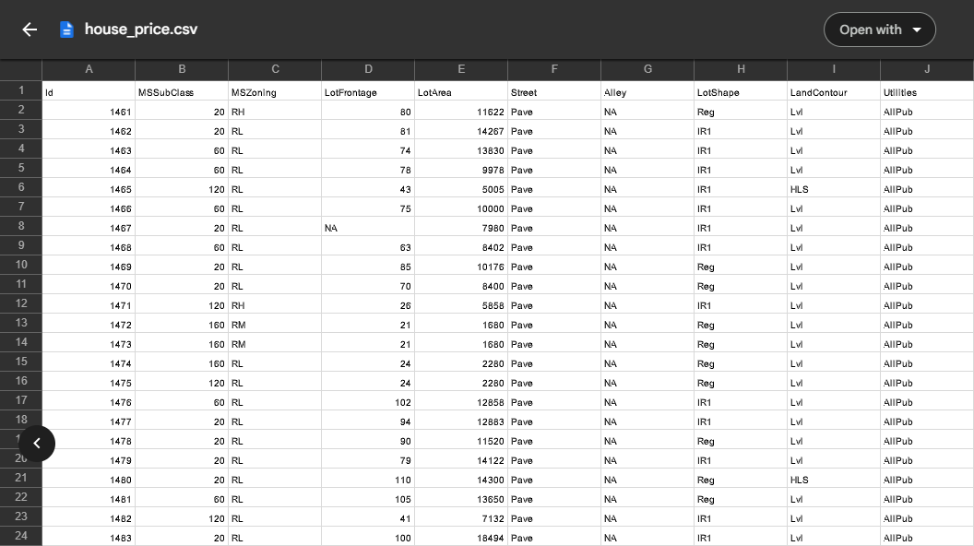

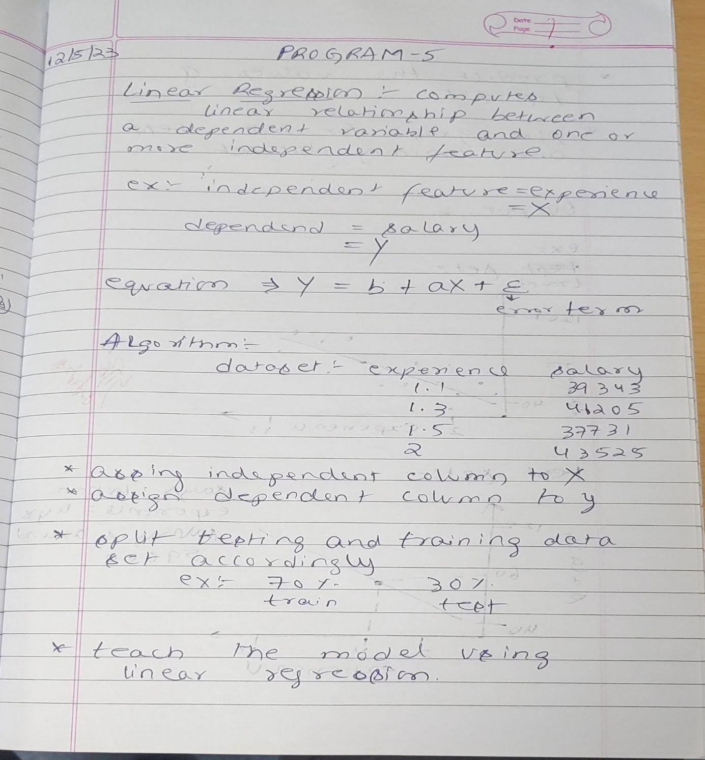

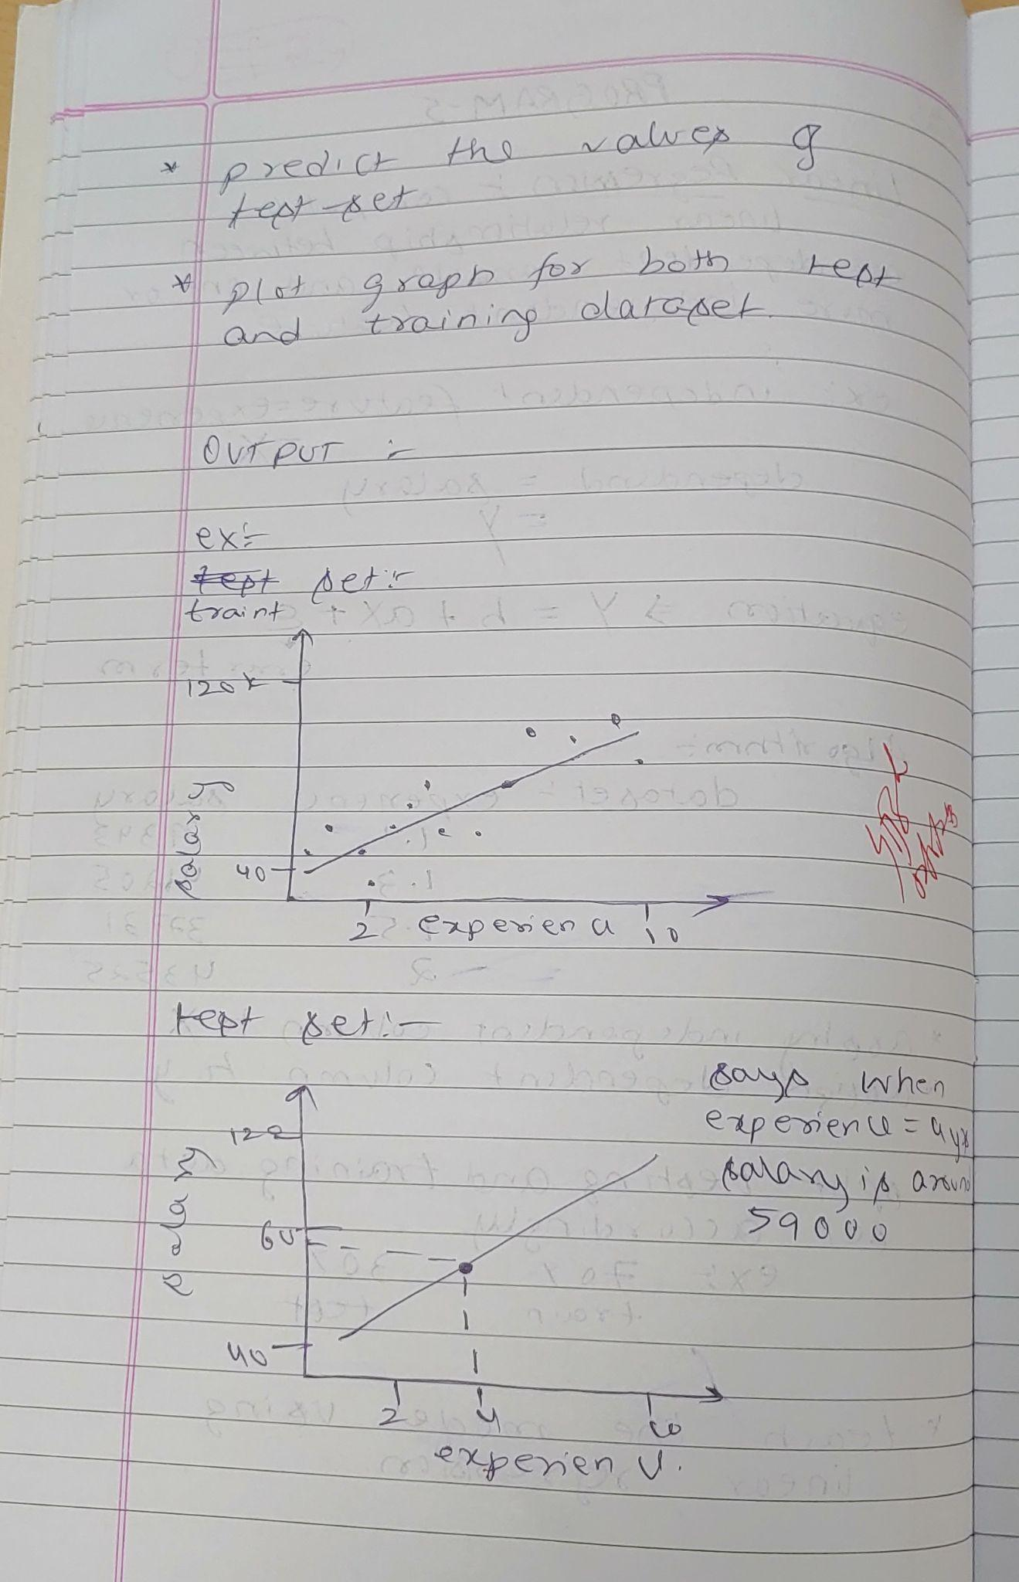**Uploading the csv file:**

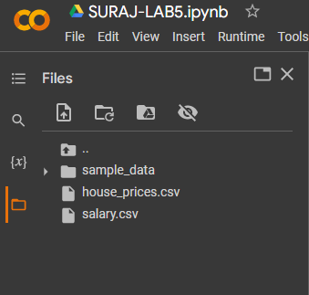

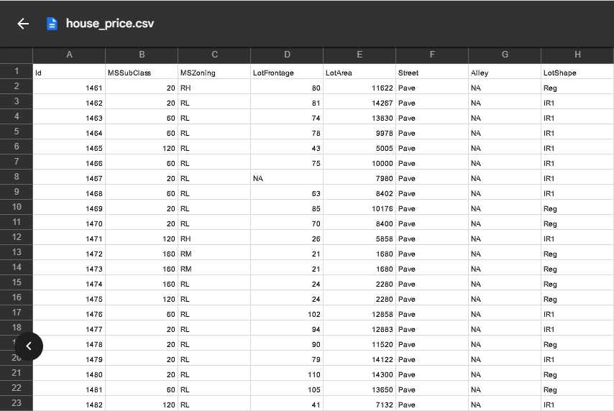

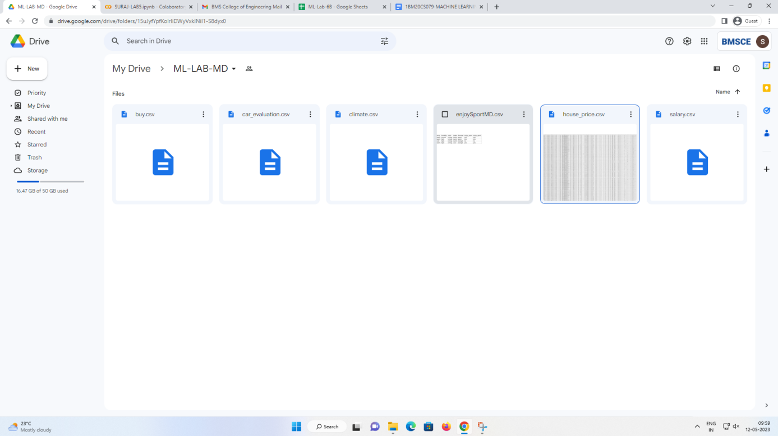

**Program:**

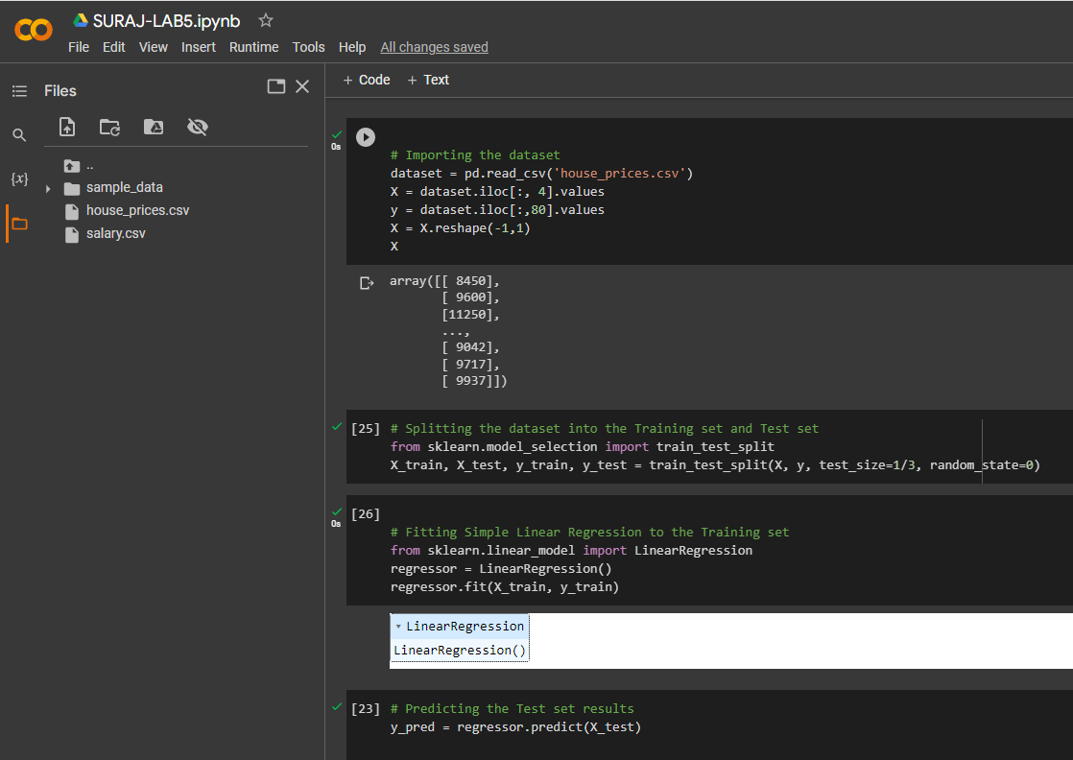

**Output:**

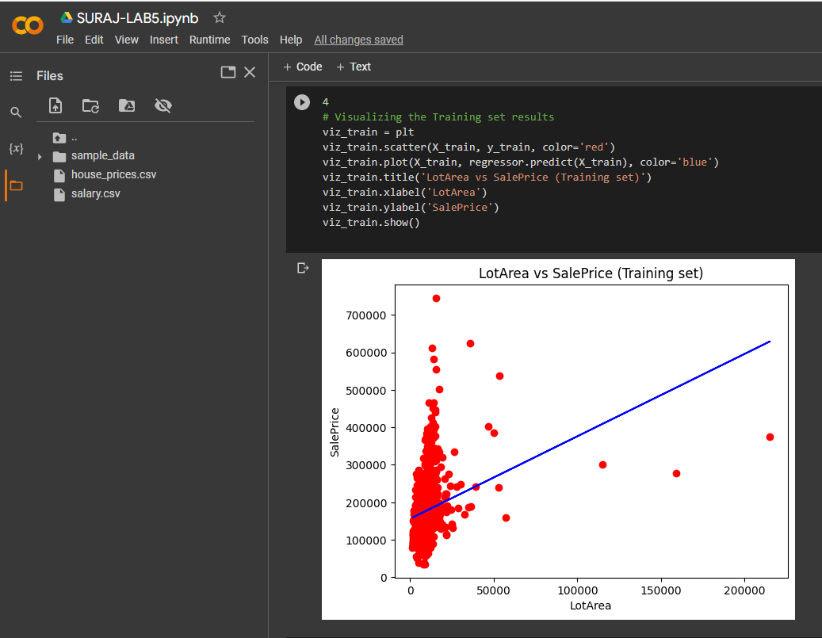

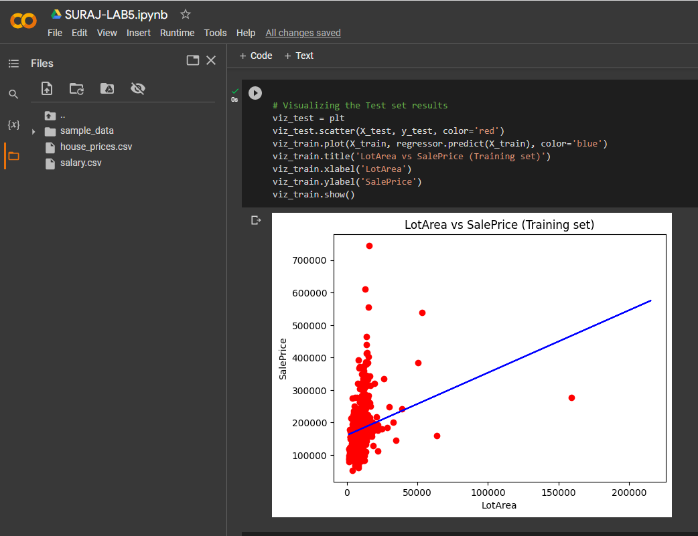

**Date: 29/5/23**

**Program 6:**

Write a program to implement the naïve Bayesian classifier for a sample training data set stored as a .CSV file. Compute the accuracy of the classifier, considering few test data sets

**Dataset:Climate.csv**

**Algorithm:**

The formula for Bayes' theorem is given as:

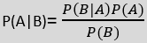

We need to follow the below steps:

1. Convert the given dataset into frequency tables.
2. Generate Likelihood table by finding the probabilities of given features.
3. Now, use Bayes theorem to calculate the posterior probability.

* Data Pre-processing step
* Fitting Naive Bayes to the Training set
* Predicting the test result
* Test accuracy of the result(Creation of Confusion matrix)
* Visualizing the test set result.

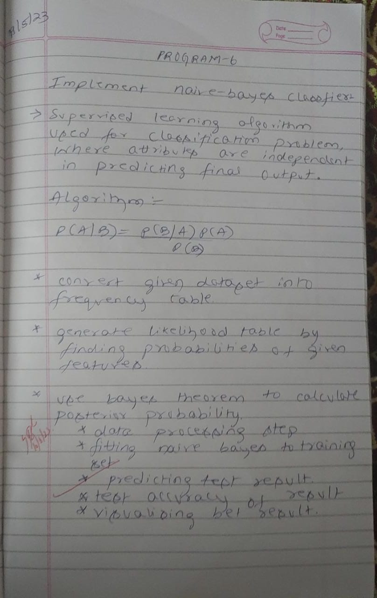

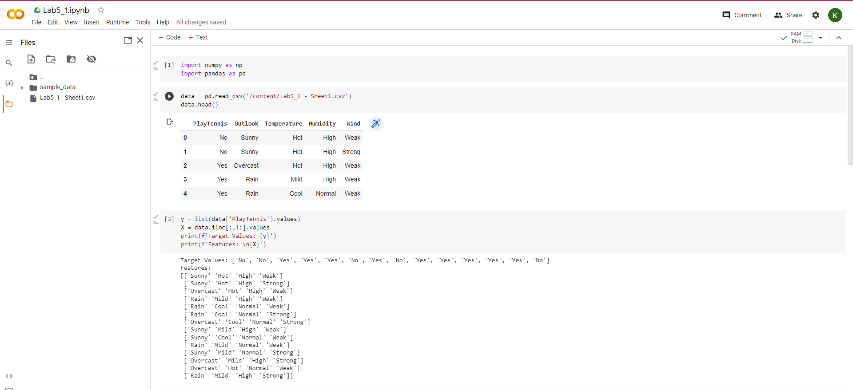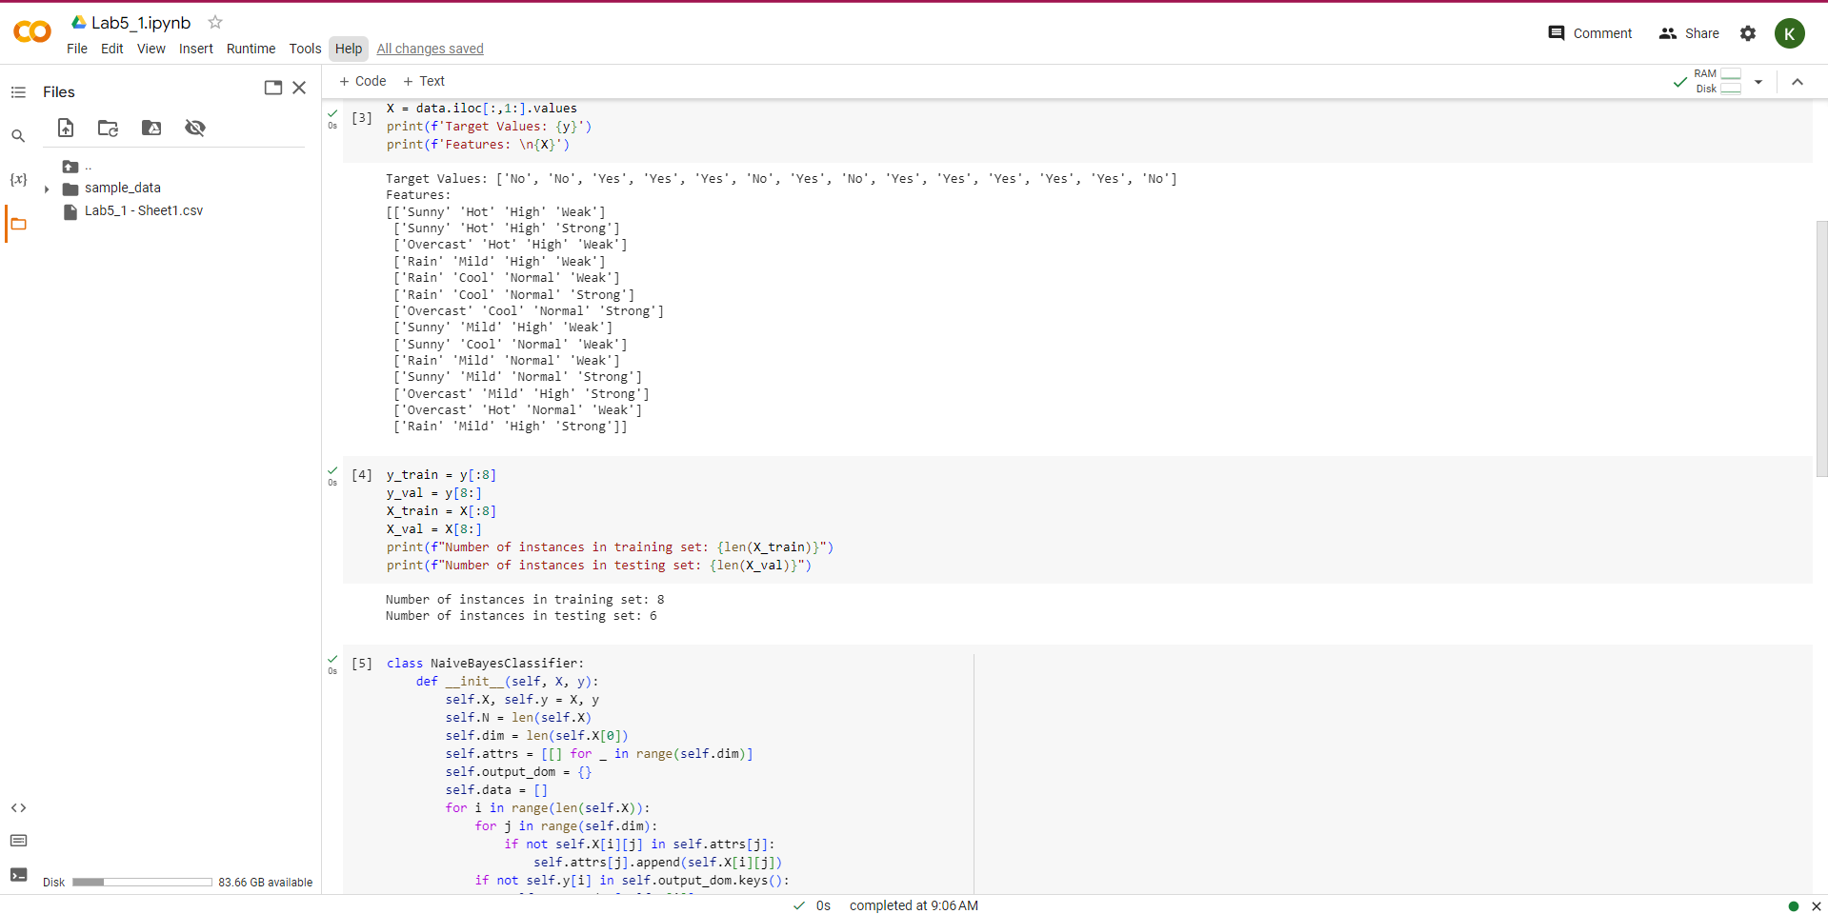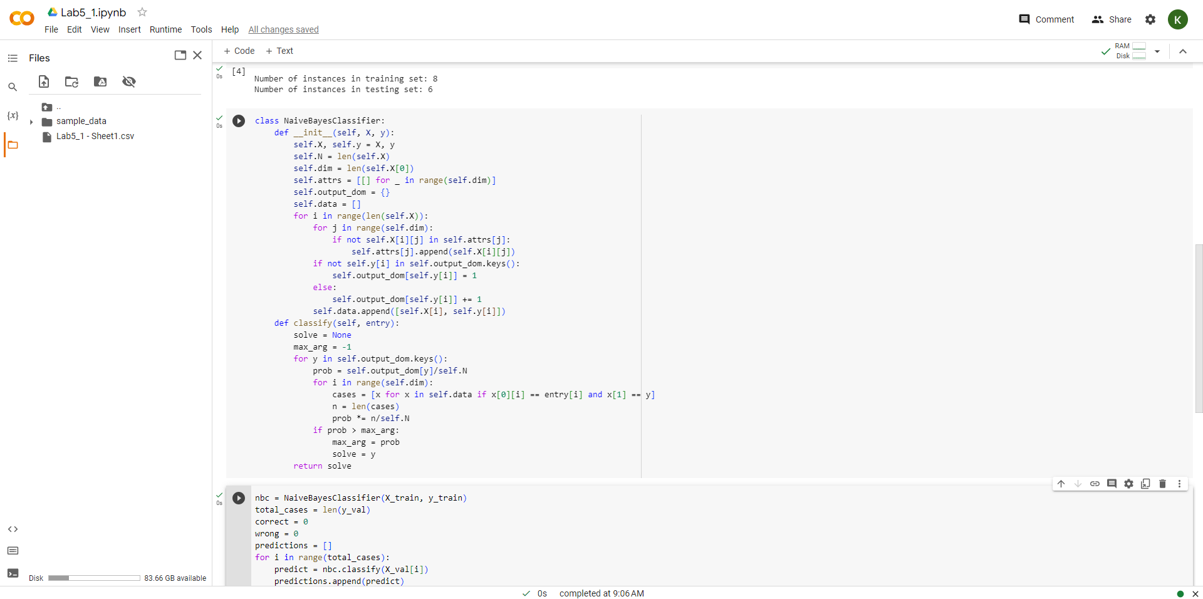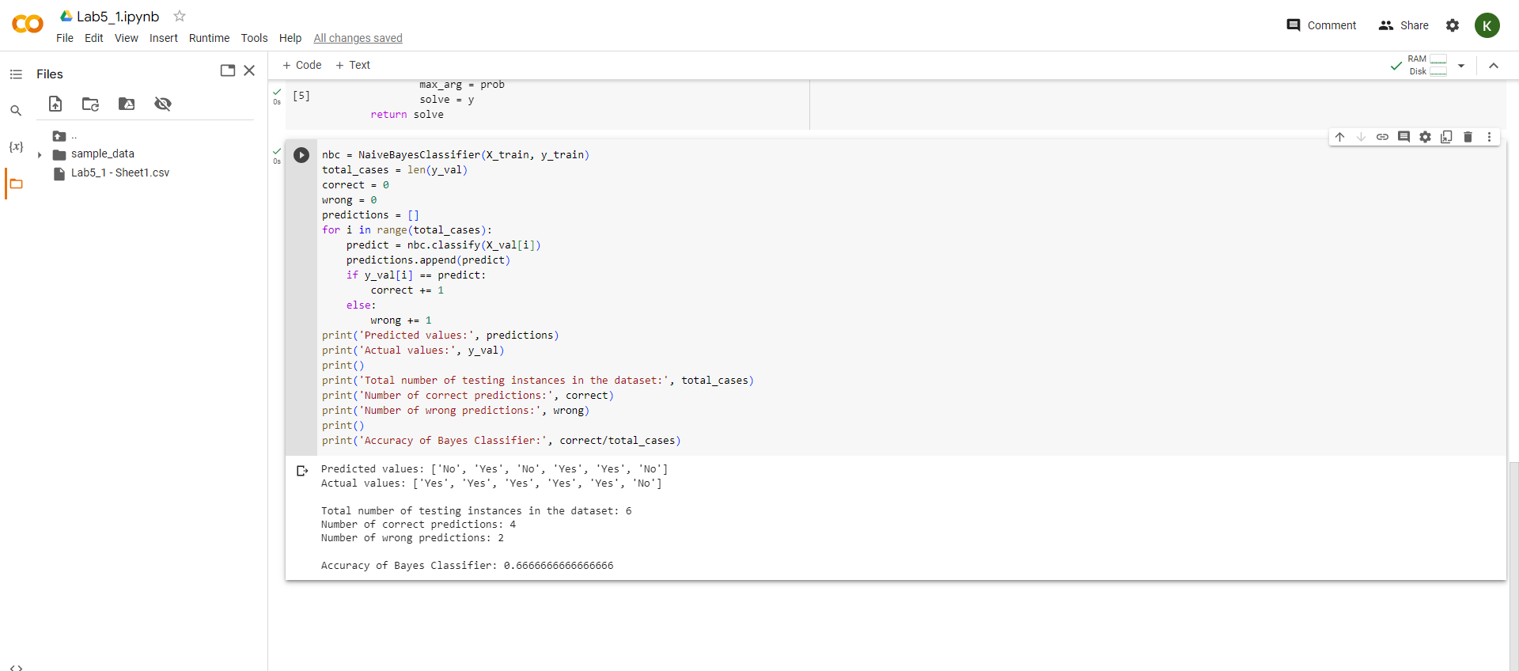

**Date: 6.05.2023**

**Program 7:**

Apply k-Means algorithm to cluster a set of data stored in a .CSV file.

Dataset : Blobs.csv

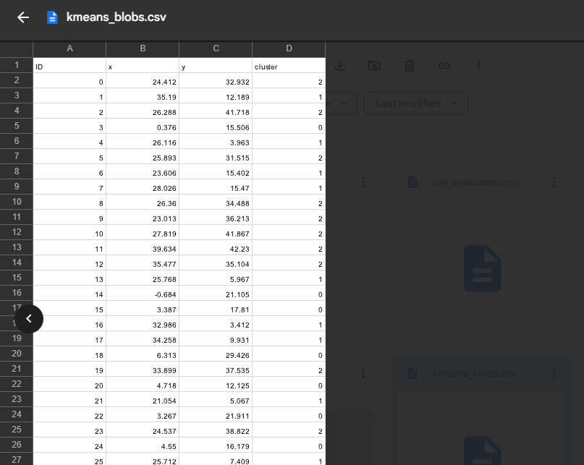

**Algorithm:**

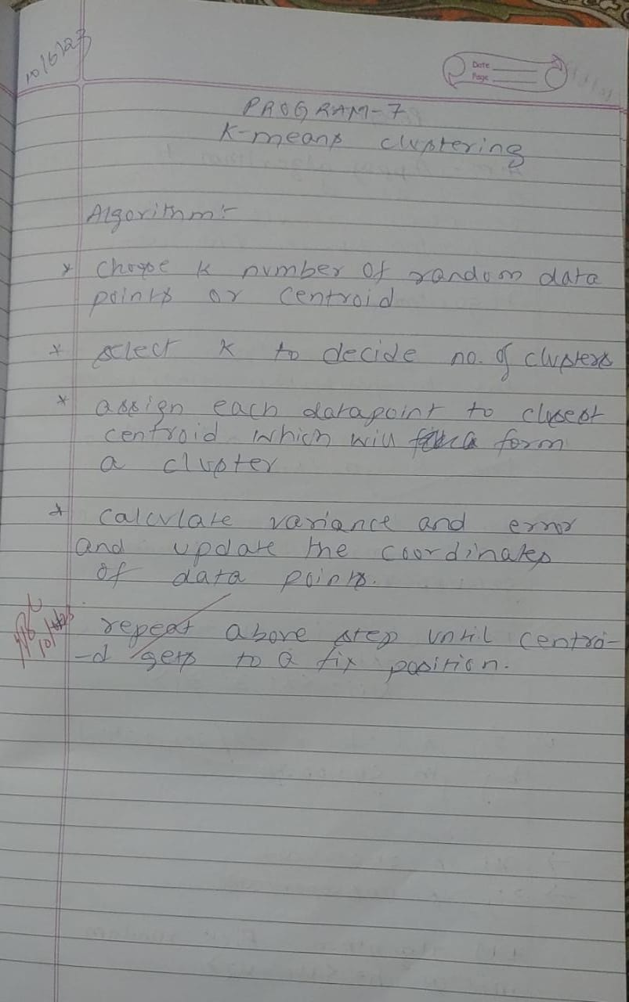

**Uploading the csv file:**



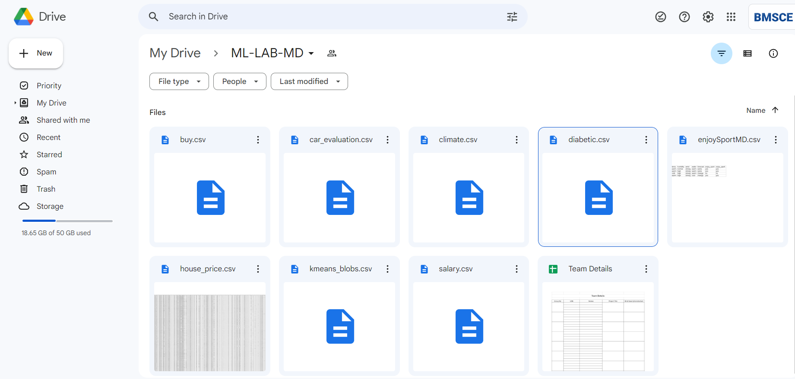

**Program:**

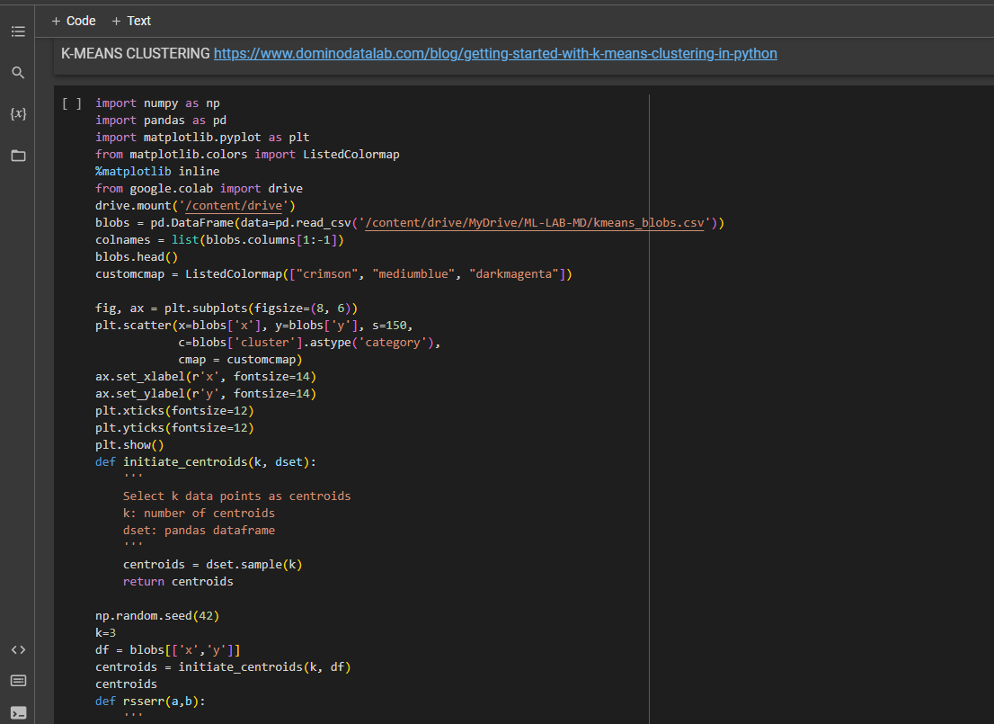

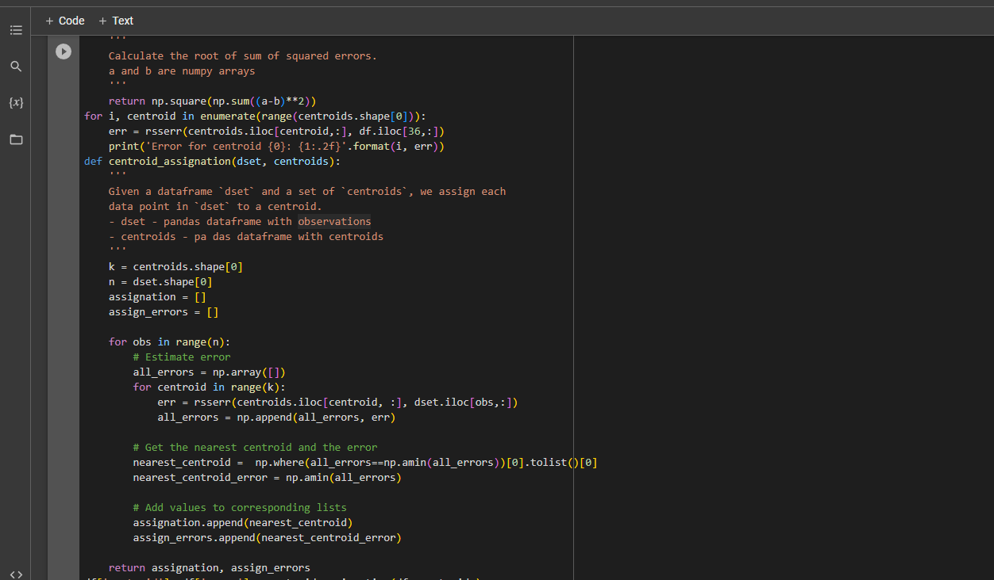

**Output:**

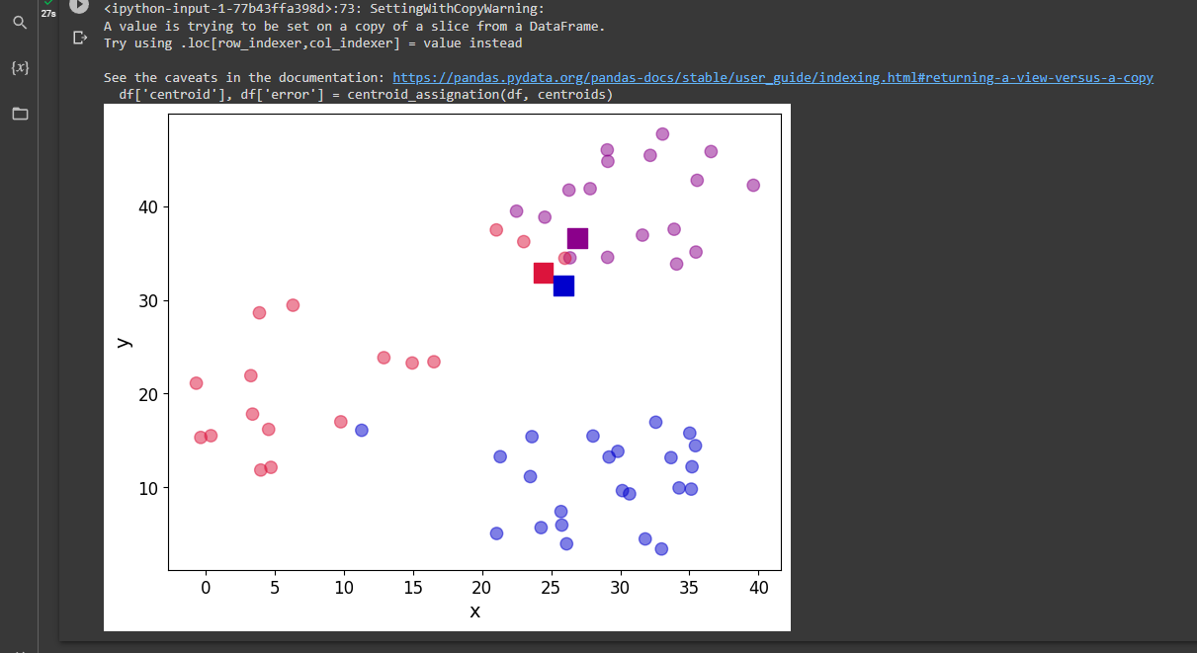

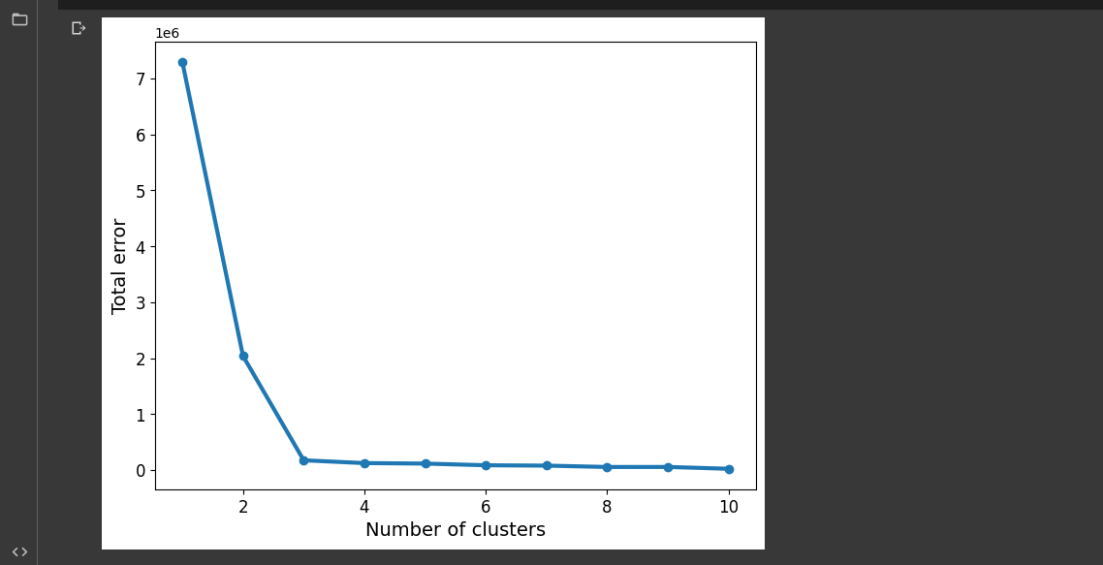

**Date: 10.05.2023**

**Program 8:**

Apply EM algorithm to cluster a set of data stored in a .CSV file. Compare the results of k-Means algorithm and EM algorithm..

Dataset : Diabetes.csv

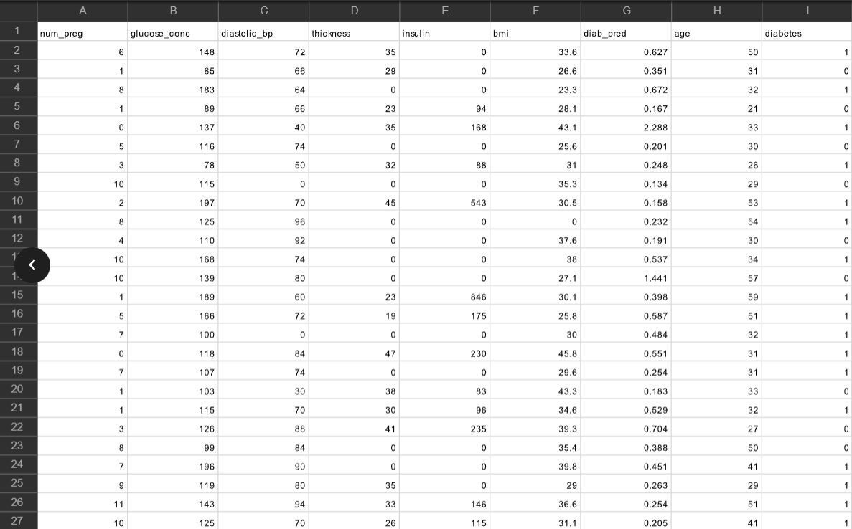

**Algorithm:**

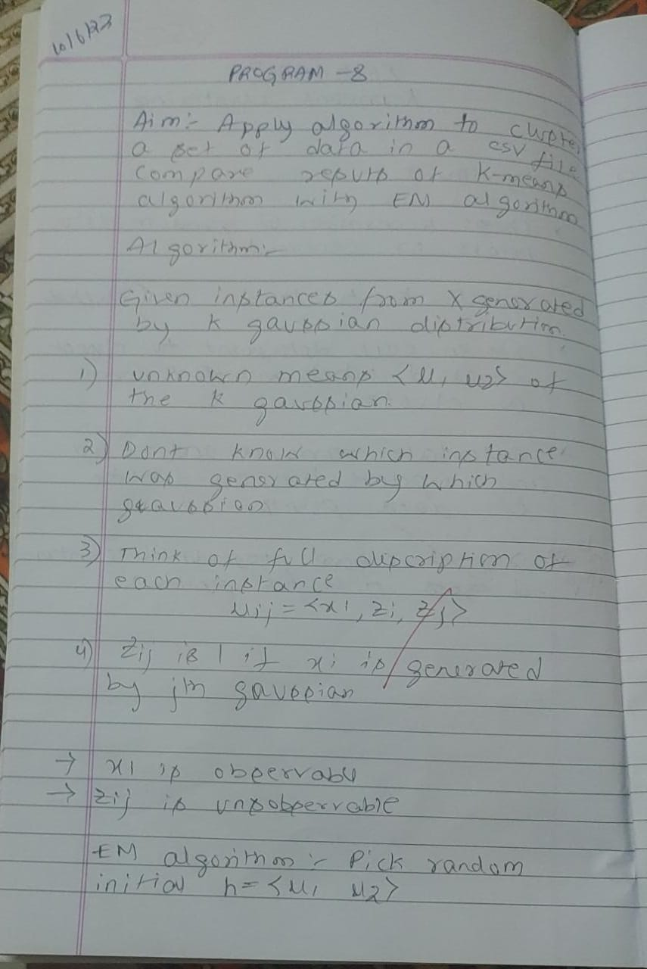

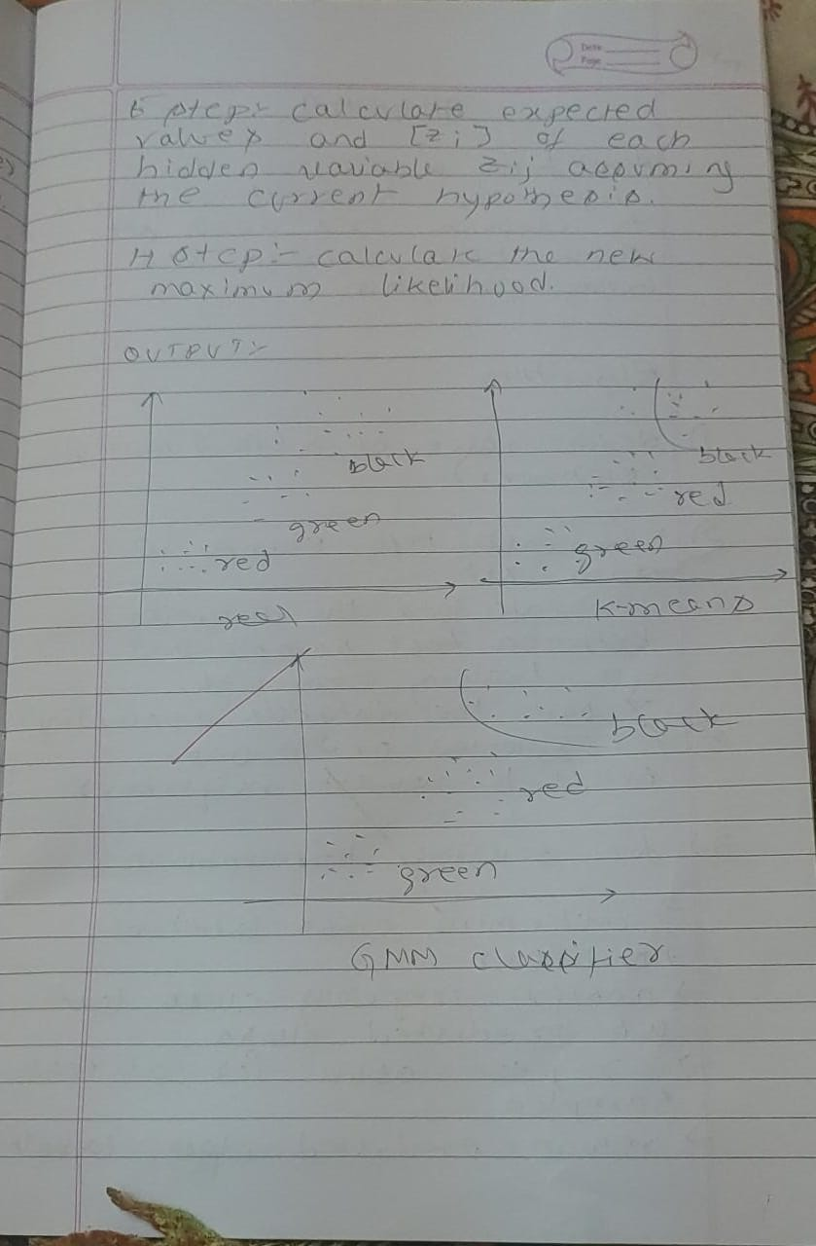**Uploading the csv file:**





**Program:**

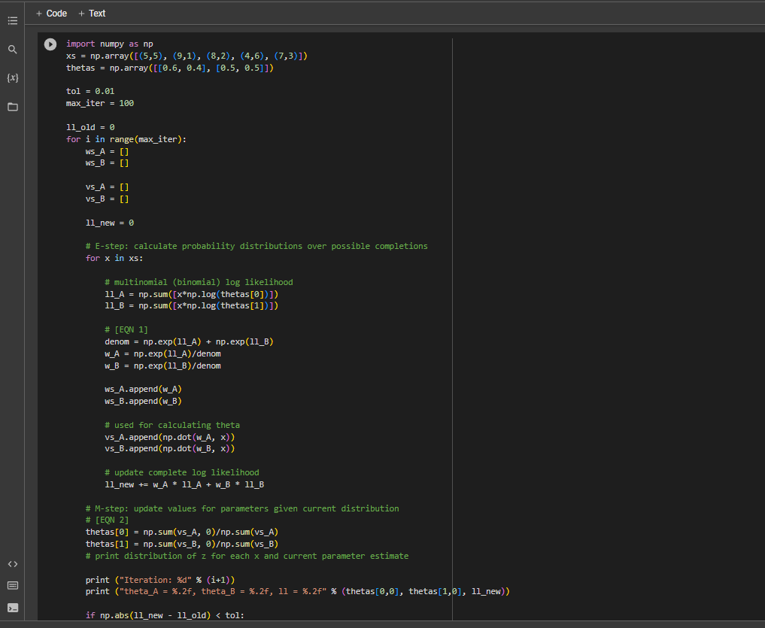

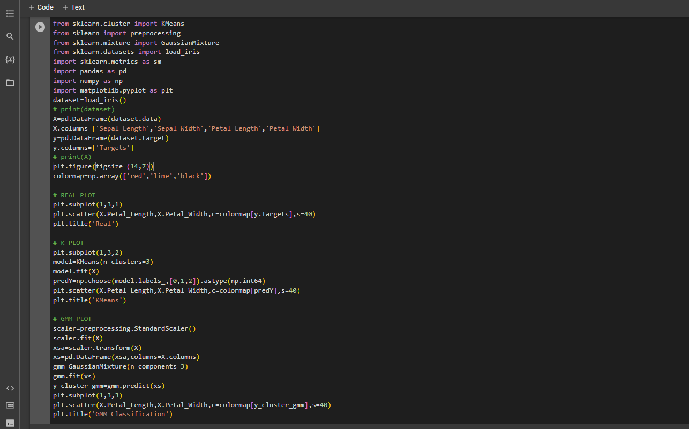

**Output:**

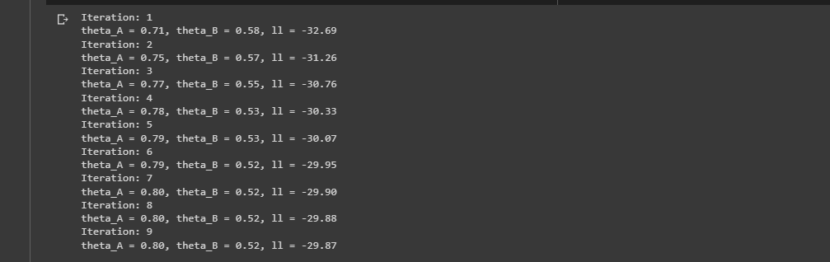

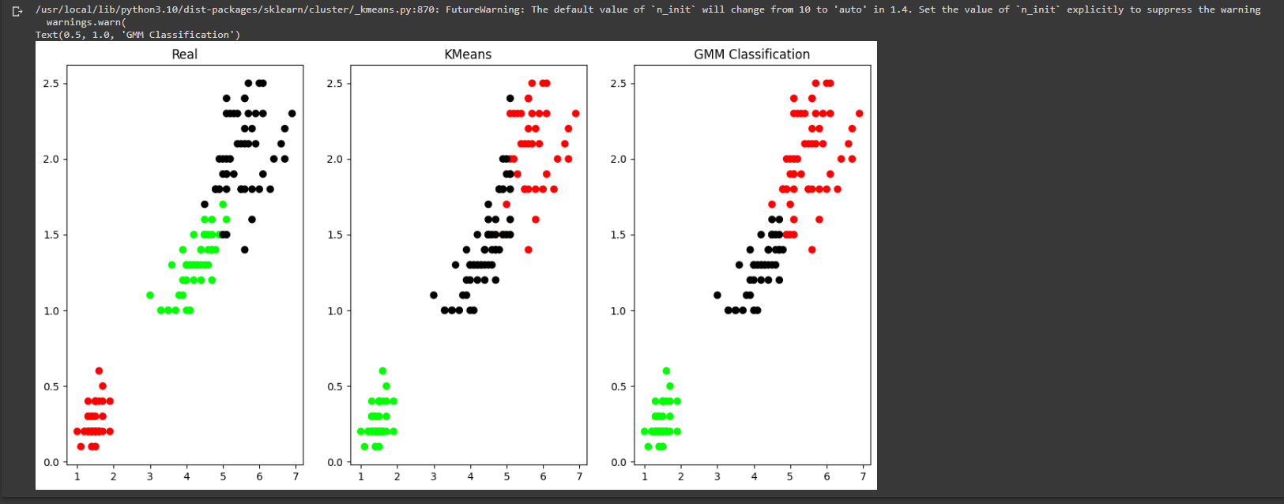

**Date: 17.05.2023**

**Program 9:**

Write a program to implement k-Nearest Neighbour algorithm to classify the iris data set. Print both correct and wrong predictions.

Dataset :kmeans_blobs.csv

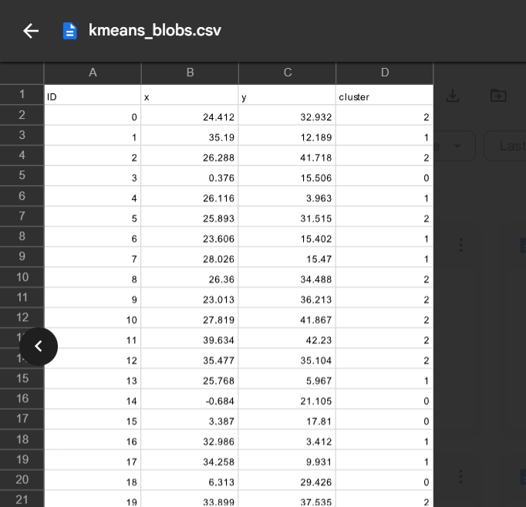

**Algorithm:**

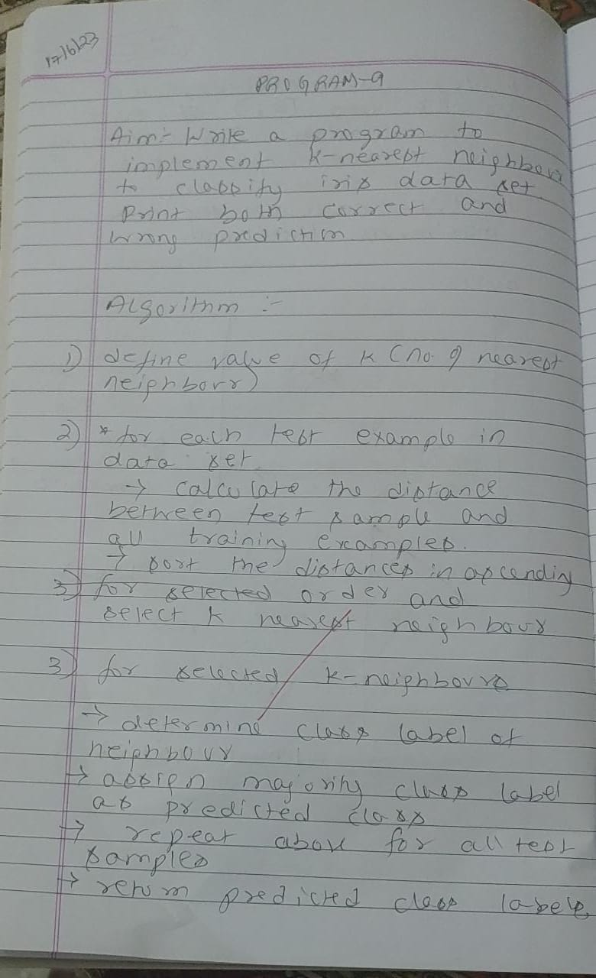

**Uploading the csv file:**

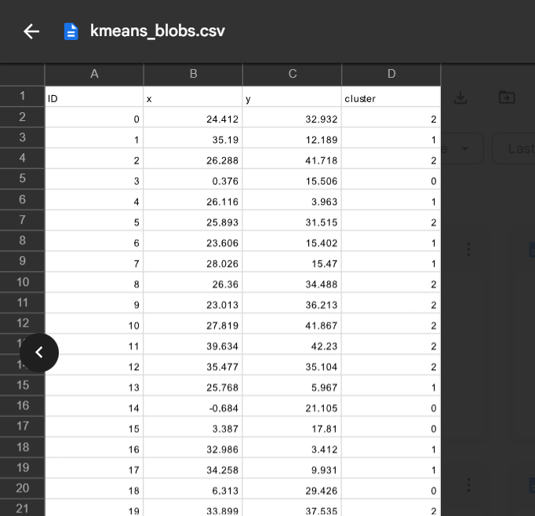



**Program:**

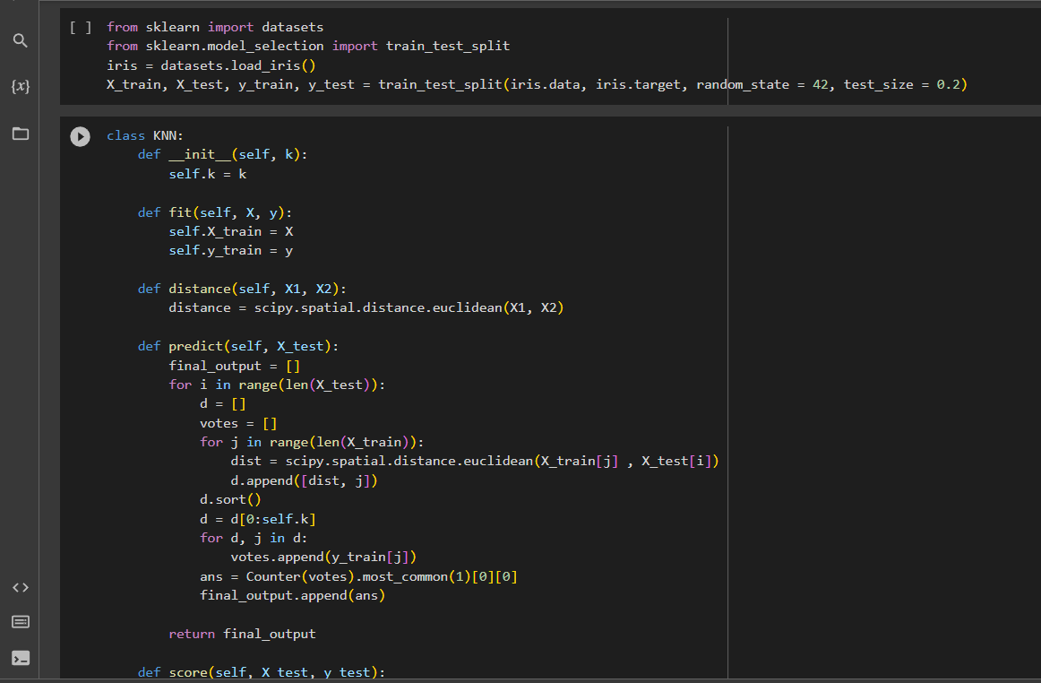

**Output:**

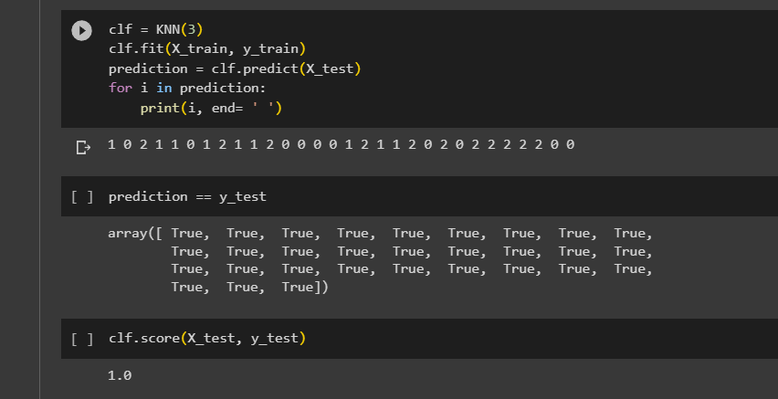

**Date: 17.05.2023**

**Program 10:**

Write a program to construct a Bayesian network considering training data. Use this model to make predictions..

Dataset :heart.csv

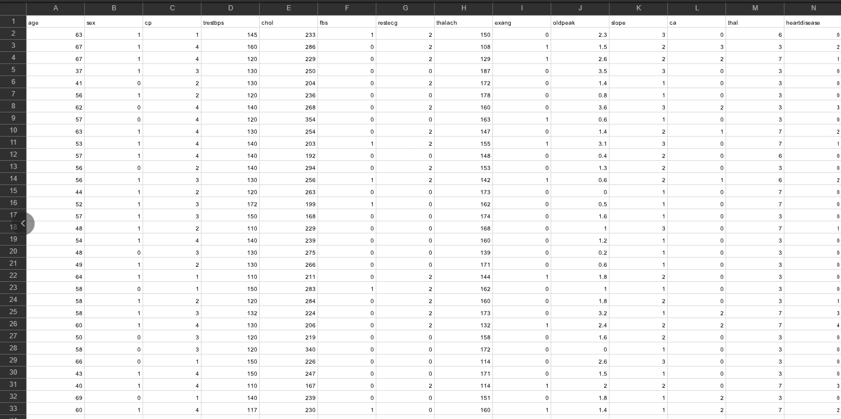

**Algorithm:**

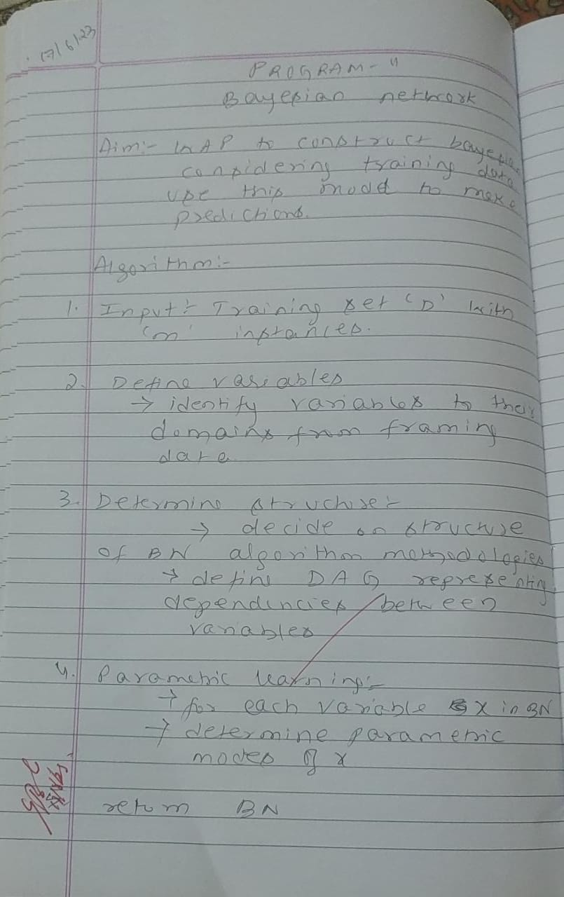

**Uploading the csv file:**



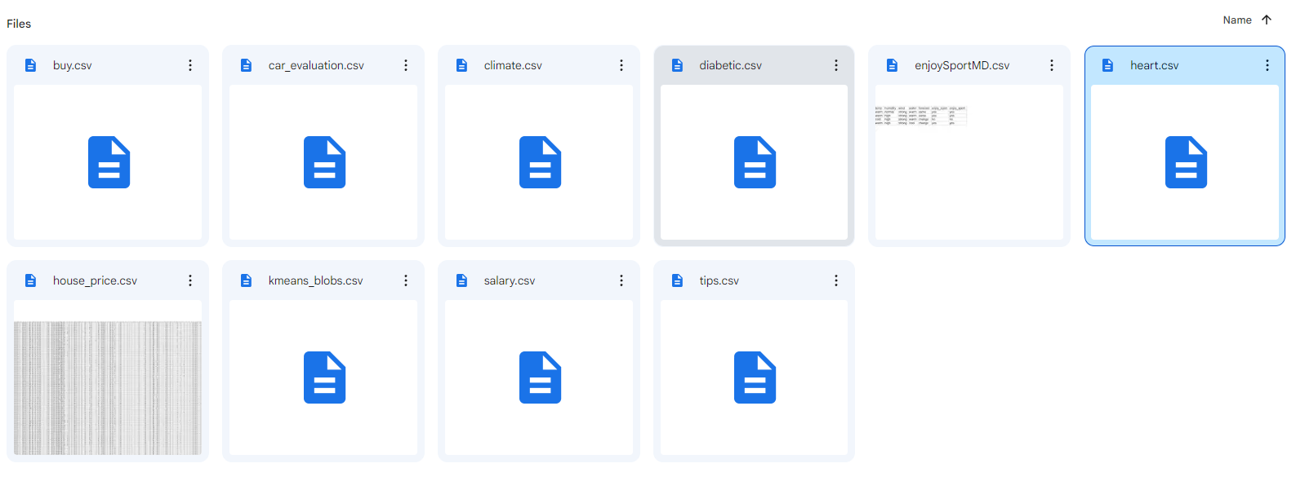

**Program:**

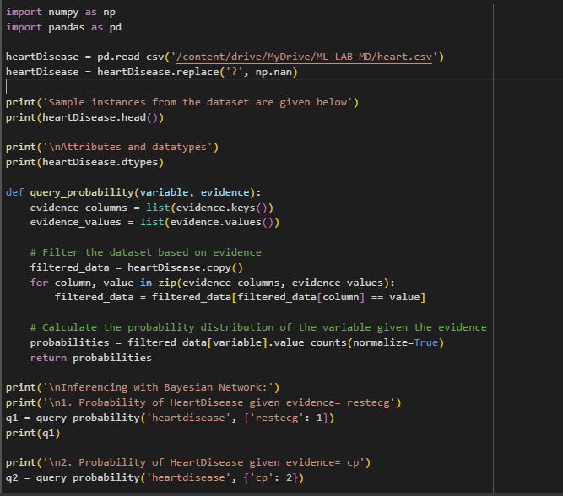

**Output:**

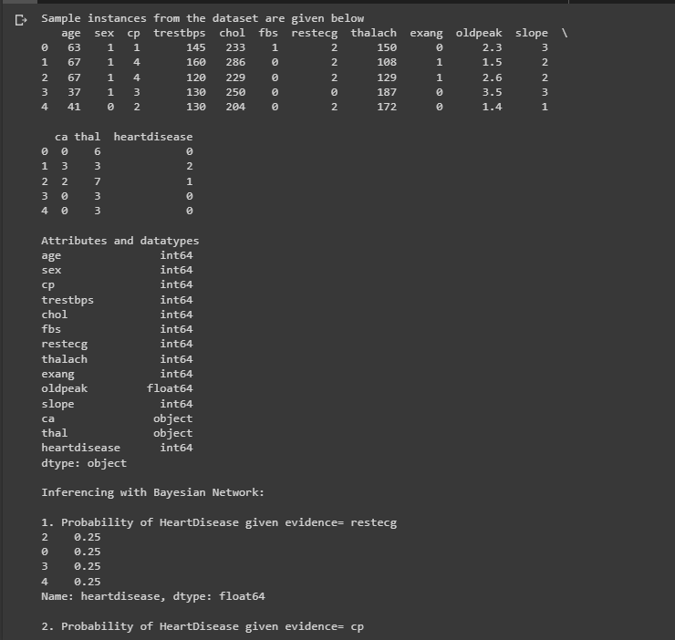

**Date: 17.05.2023**

**Program 11:**

Implement the non-parametric Locally Weighted Regression algorithm in order to fit data points. Select appropriate data set for your experiment and draw graphs.

Dataset :tips.csv

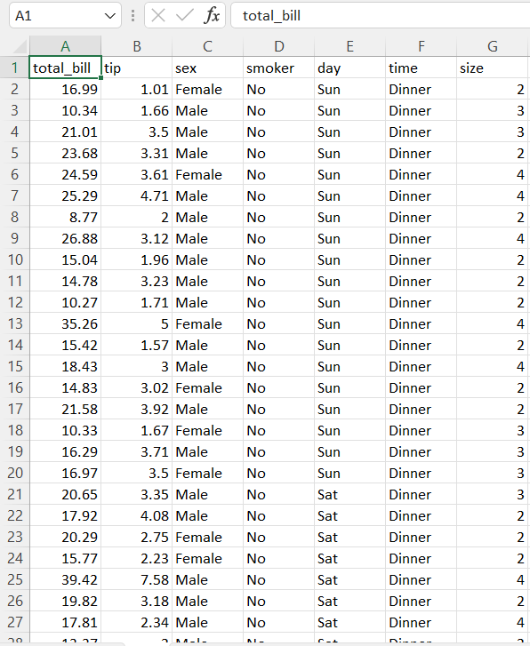

**Algorithm:**

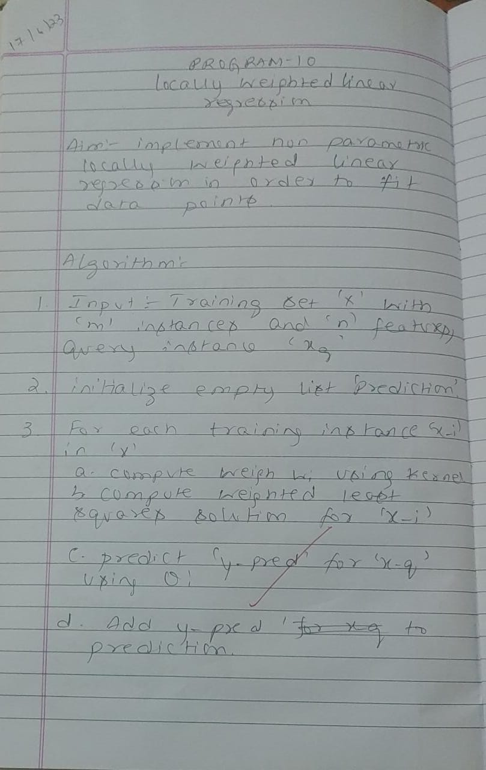

**Uploading the csv file:**



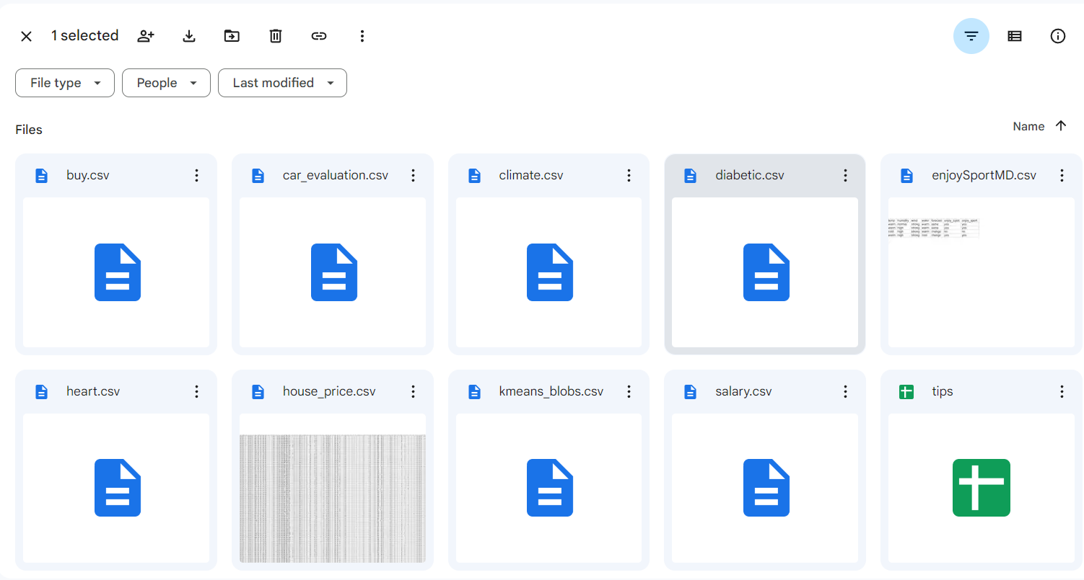

**Program:**

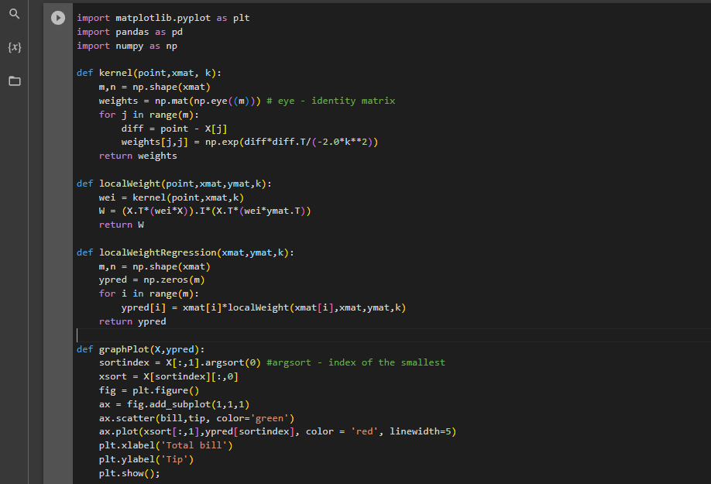

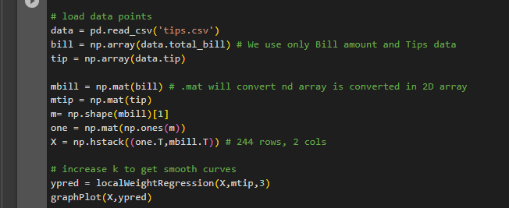

**Output:**

